N E W S R E L E A SE

FOR IMMEDIATE RELEASE- March 13, 2023
Zoe Calkins, Communications Director Arkansas Division of Workforce Services zoe.calkins@arkansas.gov

Arkansas’ Unemployment Rate Remains Stable at 3.4% in January

Little Rock, Ark., March 13, 2023- Today the Arkansas Division of Workforce Services, in conjunction with the Bureau of Labor Statistics, announced Arkansas’ seasonally adjusted unemployment rate remained stable at 3.4% in January 2023. The United States’ jobless rate declined to 3.4% in January, down from 3.5% in December.
Arkansas Civilian Labor Force Summary:

In January 2023, Arkansas’ civilian labor force rose by 478. There were 1,242 more employed compared to December 2022 and 764 fewer unemployed. Arkansas’ labor force participation rate remained unchanged between December 2022 and January 2023, at 57.4%.
- Compared to January 2022, there are 11,599 additional employed Arkansans. The unemployment rate is up two-tenths of a percentage point, with 2,787 more unemployed. Arkansas’ labor force participation rate is up one-tenth of a percentage point, from 57.3% to 57.4% over the year.
Arkansas Nonfarm Payroll Job Summary:
- In January 2023, Arkansas’ nonfarm payroll jobs declined by 12,300 to total 1,345,600. Most losses were seasonal, with Trade, Transportation, and Utilities down 4,900 jobs after the holiday season. Jobs in Government dropped 3,400, due in large part to the winter break at public colleges and universities. Gains were posted in Manufacturing, up 900 jobs.
- Compared to January 2022, nonfarm payroll jobs are up 42,700. The largest gains were in Trade, Transportation, and Utilities (+10,900), Private Education and Health Services (+7,500), Leisure and Hospitality (+6,700), and Manufacturing (+6,100).

Arkansas Civilian Labor Force (Seasonally Adjusted)

 | January  2023 | December  2022 | January  2022 | Change from December 2022 | Change from January 2022
Civilian Labor Force | 1,373,511 | 1,373,033 | 1,359,125 | 478 | 14,386
Employment | 1,326,923 | 1,325,681 | 1,315,324 | 1,242 | 11,599
Unemployment | 46,588 | 47,352 | 43,801 | -764 | 2,787
Unemployment Rate | 3.4% | 3.4% | 3.2% | 0.0% | 0.2%
Labor Force Participation Rate | 57.4% | 57.4% | 57.3% | 0.0% | 0.1%
Source: U.S. Bureau of Labor Statistics, Current Population Survey. More information about the data is available at https://www.bls.gov/cps/definitions.htm

Arkansas Nonfarm Payroll Jobs (Not Seasonally Adjusted, In Thousands)

Industry Sector based on 2022 North American Industry Classification System (NAICS) | January  2023 | December  2022 | January  2022 | Change  from December  2022 | Change  from January  2022
Total Nonfarm Payroll Jobs | 1345.6 | 1357.9 | 1302.9 | -12.3 | 42.7
Goods Producing | 227.5 | 228.0 | 218.5 | -0.5 | 9.0
Mining, Logging, & Construction | 62.8 | 64.2 | 59.9 | -1.4 | 2.9
Mining & Logging | 4.9 | 5.1 | 5.2 | -0.2 | -0.3
Construction | 57.9 | 59.1 | 54.7 | -1.2 | 3.2
Specialty Trade Contractors | 36.0 | 36.5 | 34.6 | -0.5 | 1.4
Manufacturing | 164.7 | 163.8 | 158.6 | 0.9 | 6.1
Durable Goods | 80.6 | 79.7 | 76.4 | 0.9 | 4.2
Nondurable Goods | 84.1 | 84.1 | 82.2 | 0.0 | 1.9
Service Providing | 1118.1 | 1129.9 | 1084.4 | -11.8 | 33.7
Trade, Transportation, & Utilities | 275.2 | 280.1 | 264.3 | -4.9 | 10.9
Wholesale Trade | 54.2 | 53.0 | 49.2 | 1.2 | 5.0
Retail Trade | 142.7 | 146.9 | 141.7 | -4.2 | 1.0
Transportation, Warehousing, & Utilities | 78.3 | 80.2 | 73.4 | -1.9 | 4.9
Information | 12.8 | 12.8 | 12.4 | 0.0 | 0.4
Financial Activities | 70.0 | 71.2 | 68.9 | -1.2 | 1.1
Finance & Insurance | 55.6 | 56.4 | 54.8 | -0.8 | 0.8
Real Estate, Rental, & Leasing | 14.4 | 14.8 | 14.1 | -0.4 | 0.3
Professional & Business Services | 150.1 | 150.8 | 147.7 | -0.7 | 2.4
Professional, Scientific, & Technical | 47.9 | 48.2 | 46.3 | -0.3 | 1.6
Management of Companies | 40.4 | 39.0 | 35.6 | 1.4 | 4.8
Administrative & Support Services | 61.8 | 63.6 | 65.8 | -1.8 | -4.0
Private Education & Health Services | 202.9 | 203.0 | 195.4 | -0.1 | 7.5
Private Educational Services | 18.6 | 19.2 | 17.2 | -0.6 | 1.4
Health Care & Social Assistance | 184.3 | 183.8 | 178.2 | 0.5 | 6.1
Ambulatory Health Care | 63.5 | 63.7 | 61.5 | -0.2 | 2.0
Social Assistance | 38.1 | 37.7 | 36.2 | 0.4 | 1.9
Leisure & Hospitality | 121.6 | 122.5 | 114.9 | -0.9 | 6.7
Arts, Entertainment, & Recreation | 12.0 | 12.4 | 10.9 | -0.4 | 1.1
Accommodation & Food Services | 109.6 | 110.1 | 104.0 | -0.5 | 5.6
Accommodation Services | 10.9 | 11.0 | 10.1 | -0.1 | 0.8
Food Services | 98.7 | 99.1 | 93.9 | -0.4 | 4.8
Other Services | 76.3 | 76.9 | 73.0 | -0.6 | 3.3
Government | 209.2 | 212.6 | 207.8 | -3.4 | 1.4
Federal Government | 20.6 | 20.9 | 20.6 | -0.3 | 0.0
State Government | 75.7 | 77.6 | 75.6 | -1.9 | 0.1
State Government, Educational Services | 29.5 | 31.4 | 29.2 | -1.9 | 0.3
State Government, Excluding Education | 46.2 | 46.2 | 46.4 | 0.0 | -0.2
Local Government | 112.9 | 114.1 | 111.6 | -1.2 | 1.3
Local Government, Educational Services | 70.1 | 70.8 | 69.5 | -0.7 | 0.6
Local Government, Excluding Education | 42.8 | 43.3 | 42.1 | -0.5 | 0.7
Source: Monthly Survey of Employers, based on 1st Quarter 2022 benchmark. Notes: Current month’s data are preliminary; previous month’s data are revised.

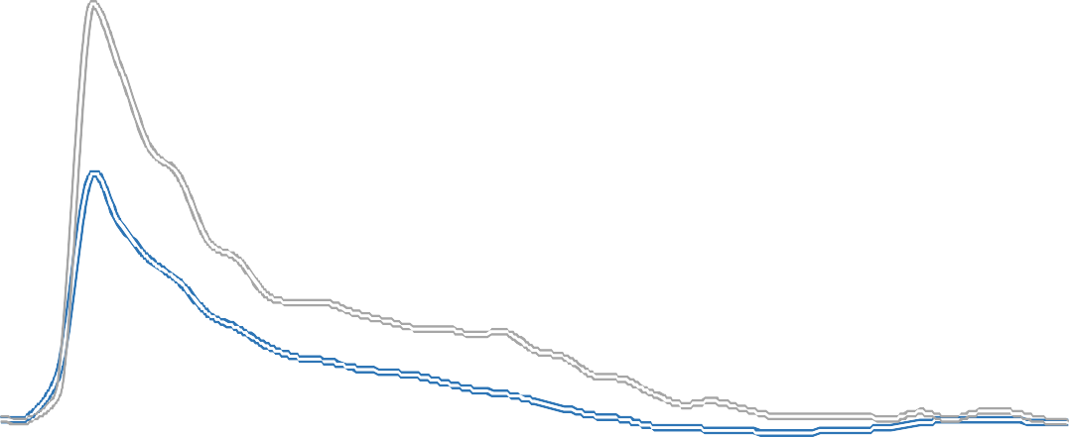Seasonally Adjusted Unemployment Rates Arkansas vs. United States (3-Year Comparison)
Arkansas
United States
16.0%

14.0%

12.0%

10.0%

8.0%

6.0%

4.0%

2.0%

0.0%
Jan '20
Jul '20
Jan '21
Jul '21
Jan '22
Jul '22
Jan '23

Job Gains/Losses by Major Industry Sectors January 2022 vs January 2023 (Not Seasonally Adjusted)
Trade-Transport-Utilities
10,900
Private Ed & Health
7,500
Leisure & Hospitality
6,700
Manufacturing
6,100
Other Services
3,300
Construction
3,200
Professional & Business
2,400
Government
1,400
Financial Activities
1,100
Information
400
Mining & Logging
-300
-2,000
0
2,000
4,000
6,000
8,000
10,000
12,000

For more Labor Market Data, visit our website at www.discover.arkansas.gov

Annual Data Revisions

Arkansas Civilian Labor Force:
In accordance with guidelines from the U.S. Department of Labor, Bureau of Labor Statistics, Arkansas’ Civilian Labor Force (CLF) estimates are undergoing annual processing. The purpose of annual processing is to incorporate more complete and accurate information into the estimation process.

All levels of data—State, counties, Metropolitan Statistical Areas (MSAs), Micropolitan Statistical Areas, Local Workforce Development Areas, and cities—are being revised. The Statewide CLF data was revised back to January 2018 and is now available at https://www.discover.arkansas.gov/Data-Search-Tool/LAUS. Updated sub-state CLF estimates are still being produced and are scheduled for publication on April 21, 2023 on the Discover Arkansas website and at www.bls.gov. All sub-state CLF data will be revised back to January 2018, due to the incorporation of updated Census Bureau population data. More information concerning annual processing is available here.

Arkansas Nonfarm Payroll Jobs:
In accordance with the same guidelines, the Current Employment Statistics program also re-estimated the Nonfarm Payroll Job series to include more comprehensive and precise information into the calculations. Statewide and MSA estimates were revised back to January 2018. All revised Nonfarm Payroll Jobs data have been updated on the Discover Arkansas website.

In addition to annual data revisions for 2018-2022, updates have also been made to the North American Industry Classification System (NAICS). All estimates are now based on and benchmarked to the 2022 NAICS. This replaces the previously used 2017 NAICS. More information concerning these changes is available here.

About the Arkansas Department of Commerce:

The Arkansas Department of Commerce is the umbrella department for workforce and economic development drivers. Its divisions and regulatory boards include Division of Aeronautics, Waterways Commission, Wine Producers Council, Division of Workforce Services, Office of Skills Development, State Bank Department, Insurance Department, Securities Department, Economic Development Commission and Development Finance Authority.

About the Arkansas Division of Workforce Services

The mission of the Arkansas Division of Workforce Services is to support and secure Arkansas' economic vitality through a highly skilled workforce by administering programs and providing services that empower employers and jobseekers. ADWS is a division of the Arkansas Department of Commerce.
www.dws.arkansas.gov | Facebook: facebook.com/arkdws | Twitter: @ArkansasDWS

About Bureau of Labor Statistics (BLS)

The Bureau of Labor Statistics measures labor market activity, working conditions, price changes, and productivity In the U.S. economy to support public and private decision making.
About Local Area Unemployment Statistics (LAUS)

The LAUS program produces monthly and annual employment, unemployment, and labor force data for Census regions and divisions, States, counties, metropolitan areas, and many cities, by place of residence.
About Current Employment Statistics (CES)

The CES program produces detailed industry estimates of employment, hours, and earnings of workers on nonfarm payrolls. CES State and Metro Area produces data for all 50 States, the District of Columbia, Puerto Rico, the Virgin Islands, and about 450 metropolitan areas and divisions.

