Labor Market Report
April

aArkadnsas Dwepartmsent
of Workforce Services

www.discover.arkansas.gov

Table of Contents

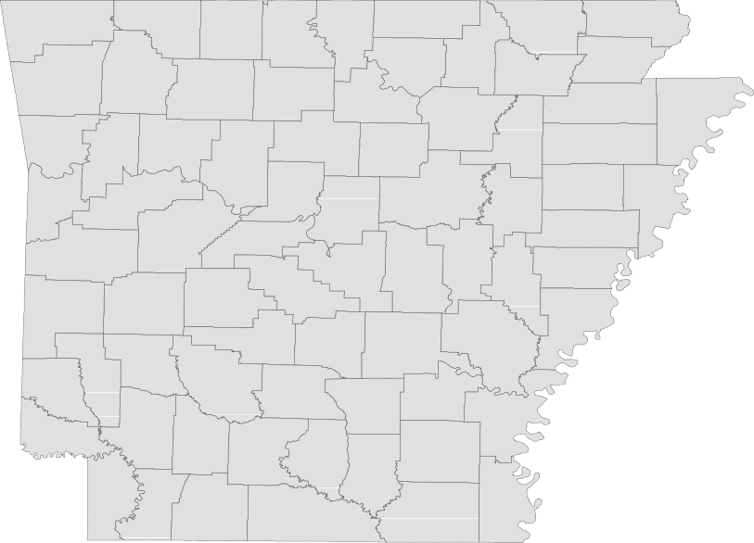

Technical Notes
Monthly Spotlight. 2
Arkansas Labor Force Summary. 3
Arkansas Nonfarm Payroll Jobs. 4
Arkansas Production Workers. 6
Metropolitan Statistical Areas. 7
Micropolitan Statistical Areas/Cities. 14
County Labor Force Statistics. 15
Local Workforce Development Areas. 18

The Arkansas Labor Market is prepared monthly in conjunction with the U.S. Depart- ment of Labor, Bureau of Labor Statistics (BLS). The current month’s estimates are preliminary, while previous month’s data is subject to revision.

Estimates of nonfarm payroll jobs show the number of jobs by industry and reflect employment by place of work. Hours and earnings estimates are based on payroll and worker-hour data collected for production workers in manufacturing industries.

Industries are classified according to the North American Industry Classification System (NAICS). All estimates are based on a first quarter 2018 benchmark.
Explanation of Terms and Concepts Monthly Business Survey of Employers
A monthly sample survey designed to provide industry information on nonfarm payroll jobs. Data are compiled each month from mail surveys and telephone interviews conducted by the Bureau of Labor Statistics in cooperation with Department of Work- force Services. The data are based on es- tablishment records and include all workers, full-or part-time, who received pay during the payroll period which includes the 12th of

the month. Approximately 5,000 Arkansas
business establishments are surveyed.
Metropolitan Statistical Area (MSA)

A term applied by the U.S. Office of Man- agement and Budget to counties that have one or more central cities and that meet specified criteria of population density, com- muting patterns and social and economic integration.
Current Population Survey (CPS)

A monthly sample survey of the popula- tion 16 years of age and over, designed to provide data on the labor force, the employed and the unemployed. The survey is conducted each month by the Bureau of the Census for BLS. The information is collected by trained interviewers from a sample of about 60,000 households. The data collected are based on the activity reported for the calendar week including the 12th of the month. Approximately 800 Arkansas households are represented in the sample survey.
Civilian Labor Force

The sum of all employed and unemployed persons 16 years of age or older. Members of the Armed Forces are excluded.

Employment

An estimate of the number of persons who worked any time for pay or profit or worked 15 hours or more as unpaid workers in a family business during the calendar week which includes the 12th of the month. Also included are those who, although not work- ing, had some job attachment and were not looking for work, and persons involved in labor management disputes.
Unemployment

An estimate of the number of persons who did not have a job, but were available for work and actively seeking work during the calendar week which includes the 12th of the month.
Unemployment Rate

The number of unemployed as a percentage of the civilian labor force. Unemployment rates are calculated from unrounded data.
Seasonal Adjustment

A statistical technique applied to monthly data to eliminate changes that normally oc- cur during the year due to seasonal events such as weather, major holidays, schedule shifts, harvest times, and the opening/clos- ing of schools.

www.discover.arkansas.gov

April Spotlight
Wages in Arkansas
The Quarterly Census of Employment and Wages (QCEW) is the most comprehensive data collection program utilized by the Bureau of Labor Statistics (BLS). The program is based on each state’s Unemploy- ment Insurance (UI) program, which enables BLS to produce data using every business that is covered under UI tax law. In addition to calculating UI covered employment, the program also tracks the wages paid to employees. Due to the extensive nature of the information, data can be produced at any level-- national, statewide, counties, and cities.

The information below comes from the QCEW program and shows annual average wage data for each county in Arkansas. Annual average wages are calculated using the total wages earned during the cal- endar year, divided by annual average employment. The wages below are compiled using all industries in the private sector, for all workers included under UI tax law. It is important to note that QCEW data is based on county of employment, not county of residency. So if an individual works in a different county than where they live, their wages are counted in the county where they work.

In 2018, average annual wages in the private sector ranged from a low of $23,100, for those employed in Newton County, to a high of $60,604 in Benton County. Compared to 2017 annual averages, wages are up in 70 Arkansas counties.
Wages in Arkansas by County
2018 Annual Average (Private Sector)

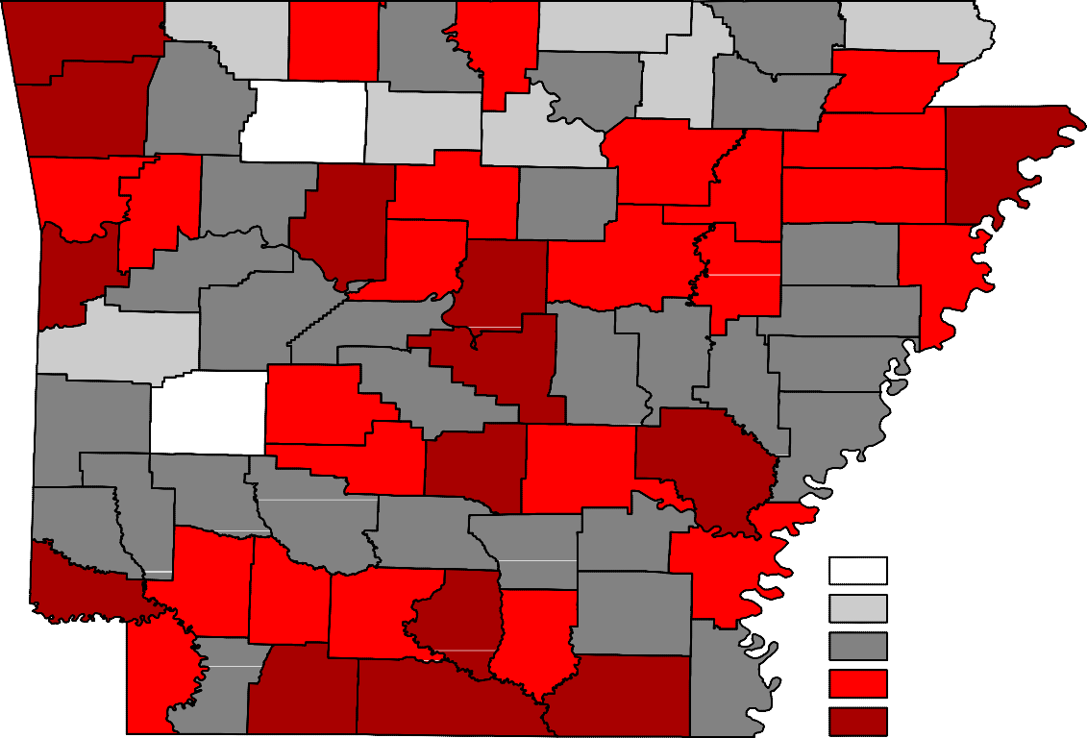
Benton
Carroll
Fulton
Clay
Boone
Randolph
Marion
Baxter
Sharp
Izard
Greene
Madison
Washington
Lawrence
Newton
Searcy
Stone
Independence
Craighead Mississippi
Crawford
Johnson
Van Buren
Jackson
Franklin
Cleburne
Poinsett
Pope
Sebastian
Logan
Conway
White
Cross
Crittenden
Faulkner
Woodruff
Yell
St. Francis
Perry
Scott
Prairie
Pulaski Lonoke
Lee
Saline
Monroe
Polk
Montgomery
Garland
Phillips
Howard
Hot Spring Grant
Jefferson
Arkansas
Pike
Sevier
Clark
Dallas
Lincoln
Cleveland
Desha
Little River Hempstead
Nevada
Ouachita
Calhoun
Drew
Bradley
Miller
fayette Columbia
Chicot
Union
Ashley
Annual Average Wages
< $25,000
$25,000 - $30,000
$30,000 - $35,000
$35,000 - $40,000
> $40,000

State of Arkansas
Civilian Labor Force Summary

Labor force data, produced by the U.S. Department of Labor, Bureau of Labor Statistics and released by the Arkansas Department of Workforce Services, show Arkansas’ seasonally adjusted unemploy- ment rate declined one-tenth of a percentage point, from 3.7 percent in March to 3.6 percent in April. Arkansas’ civilian labor force rose 1,001, a result of 2,107 more employed and 1,106 fewer unemployed Arkansans. Down two-tenths of a percentage point, the United States’ jobless rate decreased from 3.8 percent in March to 3.6 percent in April.

BLS Program Operations Manager Susan Price said, “Employment in Arkansas rose for the fourth straight month, with 10,700 more employed over-the-year. Nonfarm payroll jobs also increased, setting a new record high number of jobs in the State.”

Civilian Labor Force Estimates
Seasonally Adjusted
Not Seasonally Adjusted

Civilian Labor Force | Apr 19  1,360,466 | Mar 19  1,359,465 | Apr 18  1,350,620 | Civilian Labor Force | Apr 19  1,359,450 | Mar 19  1,357,713 | Apr 18  1,349,698
Employment | 1,310,833 | 1,308,726 | 1,300,133 | Employment | 1,320,271 | 1,311,032 | 1,304,441
Unemployment | 49,633 | 50,739 | 50,487 | Unemployment | 39,179 | 46,681 | 45,257
Unemployment Rate | 3.6 | 3.7 | 3.7 | Unemployment Rate | 2.9 | 3.4 | 3.4
U.S. Unemployment | 3.6 | 3.8 | 3.9 | U.S. Unemployment | 3.3 | 3.9 | 3.7

1,320,000
Number of Employed (Seasonally Adjusted)
April 2014 - April 2019

1,300,000

1,280,000

1,260,000

1,240,000

1,220,000

1,200,000

1,180,000
Apr '14 Oct '14 Apr '15 Oct '15 Apr '16 Oct '16 Apr '17 Oct '17 Apr '18 Oct '18 Apr '19

State of Arkansas
Nonfarm Payroll Jobs

Not Seasonally Adjusted
(In Thousands)
(NAICS)
Apr 19
Mar 19
Apr 18
OTM
OT Y

Total Nonfarm | 1279.0 | 1270.3 | 1264.7 | 8.7 | 14.3
Goods Producing | 221.5 | 220.0 | 215.2 | 1.5 | 6.3
Mining, Logging, and Construction | 58.4 | 56.1 | 55.8 | 2.3 | 2.6
Mining & Logging | 5.7 | 5.7 | 5.9 | 0.0 | -0.2
Construction | 52.7 | 50.4 | 49.9 | 2.3 | 2.8
Specialty Trade Contractors | 33.3 | 31.7 | 31.4 | 1.6 | 1.9
Manufacturing | 163.1 | 163.9 | 159.4 | -0.8 | 3.7
Durable Goods | 78.5 | 78.9 | 75.8 | -0.4 | 2.7
Nondurable Goods | 84.6 | 85.0 | 83.6 | -0.4 | 1.0
Service Providing | 1057.5 | 1050.3 | 1049.5 | 7.2 | 8.0
Trade, Transportation & Utilities | 251.6 | 250.8 | 249.8 | 0.8 | 1.8
Wholesale Trade | 48.7 | 48.1 | 47.1 | 0.6 | 1.6
Retail Trade | 138.2 | 137.7 | 138.6 | 0.5 | -0.4
Transport, Warehousing & Utilities | 64.7 | 65.0 | 64.1 | -0.3 | 0.6
Information | 11.0 | 10.9 | 11.1 | 0.1 | -0.1
Financial Activities | 60.6 | 60.2 | 60.0 | 0.4 | 0.6
Finance & Insurance | 46.9 | 46.8 | 46.5 | 0.1 | 0.4
Real Estate & Rental & Leasing | 13.7 | 13.4 | 13.5 | 0.3 | 0.2
Professional & Business Services | 148.5 | 146.4 | 148.4 | 2.1 | 0.1
Professional, Scientific & Technical | 45.4 | 44.8 | 44.4 | 0.6 | 1.0
Management of Companies | 35.2 | 35.1 | 34.8 | 0.1 | 0.4
Administrative & Support Services | 67.9 | 66.5 | 69.2 | 1.4 | -1.3
Educational & Health Services | 193.2 | 192.9 | 191.6 | 0.3 | 1.6
Educational Services | 15.9 | 16.1 | 16.3 | -0.2 | -0.4
Health Care & Social Assistance | 177.3 | 176.8 | 175.3 | 0.5 | 2.0
Ambulatory Health Care | 59.0 | 59.3 | 57.9 | -0.3 | 1.1
Social Assistance | 40.4 | 40.1 | 39.9 | 0.3 | 0.5
Leisure & Hospitality | 121.5 | 119.5 | 119.4 | 2.0 | 2.1
Arts, Entertainment & Recreation | 11.6 | 10.6 | 11.7 | 1.0 | -0.1
Accommodation & Food Services | 109.9 | 108.9 | 107.7 | 1.0 | 2.2
Accommodation Services | 11.4 | 11.1 | 11.3 | 0.3 | 0.1
Food Services | 98.5 | 97.8 | 96.4 | 0.7 | 2.1
Other Services | 53.9 | 53.3 | 53.3 | 0.6 | 0.6
Government | 217.2 | 216.3 | 215.9 | 0.9 | 1.3
Federal Government | 20.2 | 20.0 | 19.9 | 0.2 | 0.3
State Government | 80.4 | 79.9 | 80.4 | 0.5 | 0.0
Local Government | 116.6 | 116.4 | 115.6 | 0.2 | 1.0

State of Arkansas
Nonfarm Payroll Job Summary

March 2019 - April 2019
Arkansas’ nonfarm payroll employment increased 8,700 in April to total 1,279,000. Nine major industry sectors posted gains, with three adding 2,000 or more jobs, each. Employment in construction rose 2,300, due largely to seasonal hiring. Jobs in professional and business services increased 2,100. Most of the expansion occurred in administrative and support services (+1,400). Leisure and hospital- ity added 2,000 jobs. Gains were posted in both arts, entertainment, and recreation (+1,000) and in accommodation and food services (+1,000), a typical seasonal growth.

April 2018 - April 2019
Compared to April 2018, nonfarm payroll jobs have increased 14,300. Expansions were reported in nine major industry sectors. Manufacturing added 3,700 jobs, with hiring in both durable (+2,700) and nondurable (+1,000) goods manufacturing. Jobs in construction rose 2,800, related to on-going large- scale projects across the State. Employment in leisure and hospitality increased 2,100. All growth occurred in accommodation and food services (+2,200). Trade, transportation, and utilities added 1,800 jobs, mostly in wholesale trade (+1,600). Educational and health services gained 1,600 jobs, all in health care and social assistance (+2,000). Jobs in government rose 1,300. Hiring was reported in both local (+1,000) and federal (+300) government.

1,300,000

Nonfarm Payroll Jobs (Not Seasonally Adjusted)
April: 1999 - 2019

1,250,000

1,200,000

1,150,000

1,100,000

1,050,000

'99 '01 '03 '05 '07 '09 '11 '13 '15 '17 '19

State of Arkansas
Production Workers- Hours and Earnings

Manufacturing

 | Apr 19 | Mar 19 | Apr 18
Average Weekly Hours | 41.0 | 41.2 | 41.8
Average Hourly Earnings | 18.50 | 18.37 | 17.25
Average Weekly Earnings | 758.50 | 756.84 | 721.05

Durable Goods and Nondurable Goods Manufacturing
Durable Goods Manufacturing
Nondurable Goods Manufacturing
Apr 19 Mar 19 Apr 18
Average Weekly Hours 40.6 39.4
Average Hourly Earnings 16.96 17.10
Average Weekly Earnings 688.58 673.74
41.3
15.48
639.32

 | Apr 19 | Mar 19 | Apr 18
Average Weekly Hours | 41.4 | 43.2 | 42.4
Average Hourly Earnings | 20.22 | 19.68 | 19.30
Average Weekly Earnings | 837.11 | 850.18 | 818.32

$850.00
Average Weekly Earnings for Production Workers - Manufacturing
April 2016 - April 2019

$800.00

$750.00

$700.00

$650.00

$600.00

$550.00

$500.00

$450.00

Apr '16 Oct '16 Apr '17 Oct '17 Apr '18 Oct '18 Apr '19

Metropolitan Statistical Areas
Little Rock-North Little Rock-Conway MSA

The Little Rock-North Little Rock-Conway MSA = Faulkner, Grant, Lonoke, Perry, Pulaski, & Saline counties.

Civilian Labor Force Estimates (Not Seasonally Adjusted)

 | Apr 19 | Mar 19 | Apr 18 | OTM | OT Y
Civilian Labor Force | 356,049 | 356,584 | 353,718 | -535 | 2,331
Employment | 346,699 | 345,515 | 342,614 | 1,184 | 4,085
Unemployment | 9,350 | 11,069 | 11,104 | -1,719 | -1,754
Unemployment Rate | 2.6 | 3.1 | 3.1 | -0.5 | -0.5

Nonfarm Payroll Jobs (Not Seasonally Adjusted)
(In Thousands)

325.9
NAICS  Total Nonfarm | Apr 19  363.9 | Mar 19  363.3 | Apr 18  360.4 | OTM  0.6 | OT Y  3.5
Goods Producing | 37.9 | 37.4 | 37.2 | 0.5 | 0.7
Mining, Logging & Construction | 16.9 | 16.4 | 16.7 | 0.5 | 0.2
Manufacturing  Service Providing | 21.0  326.0 | 21.0 | 20.5 | 0.0 | 0.5
Trade, Transportation & Utilities | 71.1 | 71.2 | 69.7 | 0.1  -0.1 | 2.8  1.4
Wholesale Trade | 16.1 | 16.0 | 15.7 | 0.1 | 0.4
Retail Trade | 39.0 | 39.2 | 38.5 | -0.2 | 0.5
Trans., Warehousing & Utilities | 16.0 | 16.0 | 15.5 | 0.0 | 0.5
Information | 4.2 | 4.3 | 4.2 | -0.1 | 0.0
Financial Activities | 21.4 | 21.4 | 20.9 | 0.0 | 0.5
Professional & Business Services | 48.8 | 48.7 | 49.8 | 0.1 | -1.0
Educational & Health Services | 57.5 | 57.8 | 57.2 | -0.3 | 0.3
Leisure & Hospitality | 35.3 | 34.8 | 34.8 | 0.5 | 0.5
Other Services | 15.9 | 15.8 | 15.5 | 0.1 | 0.4
Government | 71.8 | 71.9 | 71.1 | -0.1 | 0.7
Federal Government | 9.7 | 9.6 | 9.6 | 0.1 | 0.1
State Government | 35.9 | 36.0 | 35.5 | -0.1 | 0.4
Local Government | 26.2 | 26.3 | 26.0 | -0.1 | 0.2

323.2

Over-the-Year Employment Change by Industry
April 2018 vs April 2019

Trade-Transport-Utilities

Government

Manufacturing

Leisure & Hospitality

Financial Activities

Other Services

Educational & Health

Mining-Logging-Construction

Information

Professional & Business

-1,500 -1,000 -500 0 500 1,000 1,500 2,000

Metropolitan Statistical Areas
Fayetteville-Springdale-Rogers MSA

The Fayetteville-Springdale-Rogers MSA = Benton, Madison, & Washington counties in Arkansas
and McDonald county in Missouri.

Civilian Labor Force Estimates (Not Seasonally Adjusted)

 | Apr 19 | Mar 19 | Apr 18 | OTM | OT Y
Civilian Labor Force | 279,104 | 279,019 | 275,462 | 85 | 3,642
Employment | 273,409 | 272,176 | 268,565 | 1,233 | 4,844
Unemployment | 5,695 | 6,843 | 6,897 | -1,148 | -1,202
Unemployment Rate | 2.0 | 2.5 | 2.5 | -0.5 | -0.5

Nonfarm Payroll Jobs (Not Seasonally Adjusted)
(In Thousands)

221.4
NAICS  Total Nonfarm | Apr 19  263.6 | Mar 19  263.1 | Apr 18  259.0 | OTM  0.5 | OT Y  4.6
Goods Producing | 41.8 | 41.7 | 40.9 | 0.1 | 0.9
Mining, Logging & Construction | 11.9 | 11.7 | 11.5 | 0.2 | 0.4
Manufacturing  Service Providing | 29.9  221.8 | 30.0 | 29.4 | -0.1 | 0.5
Trade, Transportation & Utilities | 56.5 | 56.2 | 55.4 | 0.4  0.3 | 3.7  1.1
Wholesale Trade | 12.4 | 12.4 | 12.1 | 0.0 | 0.3
Retail Trade | 26.4 | 26.0 | 26.3 | 0.4 | 0.1
Trans., Warehousing & Utilities | 17.7 | 17.8 | 17.0 | -0.1 | 0.7
Information | 2.1 | 2.1 | 2.0 | 0.0 | 0.1
Financial Activities | 8.2 | 8.2 | 8.1 | 0.0 | 0.1
Professional & Business Services | 52.0 | 51.6 | 50.6 | 0.4 | 1.4
Educational & Health Services | 30.0 | 29.9 | 29.5 | 0.1 | 0.5
Leisure & Hospitality | 25.5 | 25.8 | 26.5 | -0.3 | -1.0
Other Services | 9.4 | 9.4 | 9.1 | 0.0 | 0.3
Government | 38.1 | 38.2 | 36.9 | -0.1 | 1.2
Federal Government | 2.6 | 2.6 | 2.6 | 0.0 | 0.0
State Government | 16.1 | 16.2 | 15.1 | -0.1 | 1.0
Local Government | 19.4 | 19.4 | 19.2 | 0.0 | 0.2

218.1

Number of Employed
April: 2009 - 2019
290,000
Jobs in Service Providing Industries
January 2017 - April 2019
225,000

270,000

220,000

250,000

230,000

215,000

210,000

210,000

190,000

205,000

170,000

150,000

2009 2010 2011 2012 2013 2014 2015 2016 2017 2018 2019

200,000 J F M A M J J A S O N D
2017 2018 2019

Metropolitan Statistical Areas
Fort Smith MSA

The Fort Smith MSA = Crawford & Sebastian counties in Arkansas & LeFlore & Sequoyah counties in Oklahoma.

Civilian Labor Force Estimates (Not Seasonally Adjusted)

 | Apr 19 | Mar 19 | Apr 18 | OTM | OT Y
Civilian Labor Force | 118,592 | 118,191 | 120,290 | 401 | -1,698
Employment | 115,159 | 114,090 | 115,895 | 1,069 | -736
Unemployment | 3,433 | 4,101 | 4,395 | -668 | -962
Unemployment Rate | 2.9 | 3.5 | 3.7 | -0.6 | -0.8

Nonfarm Payroll Jobs (Not Seasonally Adjusted)
(In Thousands)

90.3
NAICS  Total Nonfarm | Apr 19  114.3 | Mar 19  112.9 | Apr 18  114.6 | OTM  1.4 | OT Y  -0.3
Goods Producing | 22.7 | 22.6 | 23.0 | 0.1 | -0.3
Mining, Logging & Construction | 5.1 | 5.0 | 5.3 | 0.1 | -0.2
Manufacturing  Service Providing | 17.6  91.6 | 17.6 | 17.7 | 0.0 | -0.1
Trade, Transportation & Utilities | 23.2 | 22.8 | 23.1 | 1.3  0.4 | 0.0  0.1
Wholesale Trade | 4.2 | 4.2 | 4.1 | 0.0 | 0.1
Retail Trade | 12.5 | 12.2 | 12.5 | 0.3 | 0.0
Trans., Warehousing & Utilities | 6.5 | 6.4 | 6.5 | 0.1 | 0.0
Information | 1.1 | 1.1 | 1.2 | 0.0 | -0.1
Financial Activities | 4.0 | 4.0 | 3.9 | 0.0 | 0.1
Professional & Business Services | 13.4 | 13.0 | 13.5 | 0.4 | -0.1
Educational & Health Services | 17.2 | 17.1 | 17.0 | 0.1 | 0.2
Leisure & Hospitality | 9.6 | 9.4 | 9.5 | 0.2 | 0.1
Other Services | 4.5 | 4.4 | 4.5 | 0.1 | 0.0
Government | 18.6 | 18.5 | 18.9 | 0.1 | -0.3
Federal Government | 1.3 | 1.3 | 1.3 | 0.0 | 0.0
State Government | 3.2 | 3.1 | 3.2 | 0.1 | 0.0
Local Government | 14.1 | 14.1 | 14.4 | 0.0 | -0.3

91.6

Civilian Labor Force
April 2016 - April 2019
128,000
Jobs in Educational and Health Services
April: 2009 - 2019
17,500

17,000

124,000

16,500

16,000

120,000

15,500

116,000

15,000

14,500

112,000
Apr '16 Oct '16 Apr '17 Oct '17 Apr '18 Oct '18 Apr '19

14,000

'09 '10 '11 '12 '13 '14 '15 '16 '17 '18 '19

Metropolitan Statistical Areas
Hot Springs MSA

The Hot Springs MSA = Garland County.

Civilian Labor Force Estimates (Not Seasonally Adjusted)

 | Apr 19 | Mar 19 | Apr 18 | OTM | OT Y
Civilian Labor Force | 41,627 | 41,314 | 41,230 | 313 | 397
Employment | 40,421 | 39,833 | 39,771 | 588 | 650
Unemployment | 1,206 | 1,481 | 1,459 | -275 | -253
Unemployment Rate | 2.9 | 3.6 | 3.5 | -0.7 | -0.6

Nonfarm Payroll Jobs (Not Seasonally Adjusted)
(In Thousands)

NAICS
Total Nonfarm Goods Producing Service Providing Government

Apr 19 | Mar 19 | Apr 18 | OTM | OT Y
39.9 | 39.4 | 39.4 | 0.5 | 0.5
4.4 | 4.4 | 4.5 | 0.0 | -0.1
35.5 | 35.0 | 34.9 | 0.5 | 0.6
4.5 | 4.6 | 4.5 | -0.1 | 0.0

40,500
Nonfarm Payroll Jobs
January 2017 - April 2019

40,000

39,500

39,000

38,500

38,000

37,500

37,000

36,500

36,000

J F M A M J J A S O N D
2017 2018 2019

Metropolitan Statistical Areas
Jonesboro MSA

The Jonesboro MSA = Craighead & Poinsett counties.

Civilian Labor Force Estimates (Not Seasonally Adjusted)

 | Apr 19 | Mar 19 | Apr 18 | OTM | OT Y
Civilian Labor Force | 64,834 | 64,538 | 63,951 | 296 | 883
Employment | 63,332 | 62,731 | 62,126 | 601 | 1,206
Unemployment | 1,502 | 1,807 | 1,825 | -305 | -323
Unemployment Rate | 2.3 | 2.8 | 2.9 | -0.5 | -0.6

Nonfarm Payroll Jobs (Not Seasonally Adjusted)
(In Thousands)

NAICS
Total Nonfarm Goods Producing Service Providing Government

Apr 19 | Mar 19 | Apr 18 | OTM | OT Y
59.3 | 58.9 | 58.1 | 0.4 | 1.2
9.9 | 9.9 | 9.9 | 0.0 | 0.0
49.4 | 49.0 | 48.2 | 0.4 | 1.2
9.1 | 9.1 | 9.1 | 0.0 | 0.0

Number of Employed
April: 1999 - 2019
65,000

60,000

55,000

50,000

45,000

40,000

35,000

30,000

'99 '00 '01 '02 '03 '04 '05 '06 '07 '08 '09 '10 '11 '12 '13 '14 '15 '16 '17 '18 '19

Metropolitan Statistical Areas
Pine Bluff MSA

The Pine Bluff MSA = Cleveland, Jefferson, & Lincoln counties.

Civilian Labor Force Estimates (Not Seasonally Adjusted)

 | Apr 19 | Mar 19 | Apr 18 | OTM | OT Y
Civilian Labor Force | 35,173 | 35,277 | 35,249 | -104 | -76
Employment | 33,658 | 33,516 | 33,655 | 142 | 3
Unemployment | 1,515 | 1,761 | 1,594 | -246 | -79
Unemployment Rate | 4.3 | 5.0 | 4.5 | -0.7 | -0.2

Nonfarm Payroll Jobs (Not Seasonally Adjusted)
(In Thousands)

NAICS
Total Nonfarm Goods Producing Service Providing Government

Apr 19 | Mar 19 | Apr 18 | OTM | OT Y
33.2 | 33.3 | 33.3 | -0.1 | -0.1
5.9 | 5.9 | 6.1 | 0.0 | -0.2
27.3 | 27.4 | 27.2 | -0.1 | 0.1
9.2 | 9.3 | 9.3 | -0.1 | -0.1

10.0
Unemployment Rates
April 2014 - April 2019

9.0

8.0

7.0

6.0

5.0

4.0

3.0

2.0

1.0

0.0
Apr '14 Oct '14 Apr '15 Oct '15 Apr '16 Oct '16 Apr '17 Oct '17 Apr '18 Oct '18 Apr '19

Metropolitan Statistical Areas
Out-of-State MSA

Civilian Labor Force Estimates (Not Seasonally Adjusted)

Memphis, TN-MS-AR MSA

The Memphis, TN-MS-AR MSA = Fayette, Shelby, & Tipton counties in Tennessee; Benton, Desoto, Marshall, Tate, & Tunica counties in Mississippi; & Crittenden County in Arkansas.

 | Apr 19 | Mar 19 | Apr 18 | OTM | OT Y
Civilian Labor Force | 642,837 | 642,312 | 630,603 | 525 | 12,234
Employment | 620,166 | 617,057 | 606,740 | 3,109 | 13,426
Unemployment | 22,671 | 25,255 | 23,863 | -2,584 | -1,192
Unemployment Rate | 3.5 | 3.9 | 3.8 | -0.4 | -0.3

Texarkana MSA
The Texarkana MSA= Bowie County in Texas & Little River & Miller counties in Arkansas.

 | Apr 19 | Mar 19 | Apr 18 | OTM | OT Y
Civilian Labor Force | 64,645 | 64,944 | 64,247 | -299 | 398
Employment | 62,251 | 62,046 | 61,581 | 205 | 670
Unemployment | 2,394 | 2,898 | 2,666 | -504 | -272
Unemployment Rate | 3.7 | 4.5 | 4.1 | -0.8 | -0.4

Memphis MSA - Civilian Labor Force
April: 2009 - 2019
Texarkana MSA - Number of Employed
January 2017 - April 2019
63,000

660,000

640,000

62,000

620,000

61,000

600,000

60,000

580,000

560,000

'09 '10 '11 '12 '13 '14 '15 '16 '17 '18 '19

59,000 J F M A M J J A S O N D
2017 2018 2019

Micropolitan Statistical Areas and Cities
Civilian Labor Force Estimates
Micropolitan Labor Force Estimates
Not Seasonally Adjusted
Micro Area
April 2019
CLF Emp Unemp Rate
March 2019
CLF Emp Unemp Rate
April 2018
CLF Emp Unemp Rate

Arkadelphia Micro | 9,974 | 9,646 | 328 | 3.3 | 9,910 | 9,617 | 293 | 3.0 | 9,518 | 9,217 | 301 | 3.2
Batesville Micro | 16,614 | 16,106 | 508 | 3.1 | 16,644 | 16,045 | 599 | 3.6 | 16,062 | 15,506 | 556 | 3.5
Blytheville Micro | 17,060 | 16,386 | 674 | 4.0 | 17,078 | 16,268 | 810 | 4.7 | 17,324 | 16,443 | 881 | 5.1
Camden Micro | 12,406 | 11,844 | 562 | 4.5 | 12,402 | 11,746 | 656 | 5.3 | 12,136 | 11,628 | 508 | 4.2
El Dorado Micro | 15,854 | 15,169 | 685 | 4.3 | 15,937 | 15,137 | 800 | 5.0 | 15,919 | 15,048 | 871 | 5.5
Forrest City Micro | 8,275 | 7,901 | 374 | 4.5 | 8,274 | 7,825 | 449 | 5.4 | 8,295 | 7,924 | 371 | 4.5
Harrison Micro | 19,506 | 18,995 | 511 | 2.6 | 19,528 | 18,896 | 632 | 3.2 | 19,294 | 18,659 | 635 | 3.3
Helena-West Helena Micro | 6,564 | 6,254 | 310 | 4.7 | 6,526 | 6,144 | 382 | 5.9 | 6,661 | 6,275 | 386 | 5.8
Hope Micro | 13,840 | 13,362 | 478 | 3.5 | 13,708 | 13,207 | 501 | 3.7 | 13,518 | 13,116 | 402 | 3.0
Magnolia Micro | 9,132 | 8,810 | 322 | 3.5 | 9,163 | 8,782 | 381 | 4.2 | 9,028 | 8,641 | 387 | 4.3
Malvern Micro | 13,944 | 13,535 | 409 | 2.9 | 13,946 | 13,447 | 499 | 3.6 | 14,015 | 13,527 | 488 | 3.5
Mountain Home Micro | 16,449 | 15,921 | 528 | 3.2 | 16,473 | 15,789 | 684 | 4.2 | 16,414 | 15,818 | 596 | 3.6
Paragould Micro | 20,139 | 19,611 | 528 | 2.6 | 20,113 | 19,449 | 664 | 3.3 | 19,773 | 19,183 | 590 | 3.0
Russellville Micro | 37,806 | 36,580 | 1,226 | 3.2 | 37,702 | 36,215 | 1,487 | 3.9 | 37,602 | 36,270 | 1,332 | 3.5
Searcy Micro | 33,945 | 32,606 | 1,339 | 3.9 | 34,051 | 32,459 | 1,592 | 4.7 | 33,954 | 32,567 | 1,387 | 4.1

Arkadelphia Micro = Clark County
Batesville Micro = Independence County Blytheville Micro = Mississippi County
Camden Micro = Calhoun & Ouachita counties
El Dorado Micro = Union County
Forrest City Micro = St. Francis County
Harrison Micro = Boone & Newton counties Helena-West Helena Micro = Phillips County Hope Micro = Hempstead & Nevada counties Magnolia Micro = Columbia County

City Labor Force Statistics
Malvern Micro = Hot Spring County
Mountain Home Micro = Baxter County Paragould Micro = Greene County Russellville Micro = Pope & Yell counties Searcy Micro = White County

City
CLF
April 2019
Emp Unemp
Not Seasonally Adjusted
March 2019
Rate
CLF
Emp Unemp
Rate
April 2018
CLF Emp Unemp Rate
www.discover.arkansas.gov
14

Bella Vista | 12,407 | 12,037 | 370 | 3.0 | 12,417 | 11,983 | 434 | 3.5 | 12,245 | 11,811 | 434 | 3.5
Benton | 17,239 | 16,832 | 407 | 2.4 | 17,281 | 16,785 | 496 | 2.9 | 17,126 | 16,632 | 494 | 2.9
Bentonville | 26,484 | 26,027 | 457 | 1.7 | 26,467 | 25,911 | 556 | 2.1 | 26,204 | 25,539 | 665 | 2.5
Blytheville | 5,771 | 5,542 | 229 | 4.0 | 5,782 | 5,502 | 280 | 4.8 | 5,850 | 5,561 | 289 | 4.9
Cabot | 11,992 | 11,682 | 310 | 2.6 | 11,970 | 11,606 | 364 | 3.0 | 11,906 | 11,552 | 354 | 3.0
Conway | 33,635 | 32,807 | 828 | 2.5 | 33,622 | 32,691 | 931 | 2.8 | 33,372 | 32,426 | 946 | 2.8
El Dorado | 6,933 | 6,553 | 380 | 5.5 | 6,967 | 6,539 | 428 | 6.1 | 6,928 | 6,501 | 427 | 6.2
Fayetteville | 48,115 | 47,142 | 973 | 2.0 | 48,105 | 46,940 | 1,165 | 2.4 | 47,377 | 46,263 | 1,114 | 2.4
Fort Smith | 39,573 | 38,535 | 1,038 | 2.6 | 39,357 | 38,095 | 1,262 | 3.2 | 39,995 | 38,559 | 1,436 | 3.6
Hot Springs | 14,800 | 14,342 | 458 | 3.1 | 14,697 | 14,134 | 563 | 3.8 | 14,703 | 14,112 | 591 | 4.0
Jacksonville | 11,763 | 11,353 | 410 | 3.5 | 11,772 | 11,321 | 451 | 3.8 | 11,642 | 11,217 | 425 | 3.7
Jonesboro | 38,412 | 37,499 | 913 | 2.4 | 38,220 | 37,184 | 1,036 | 2.7 | 37,821 | 36,774 | 1,047 | 2.8
Little Rock | 97,833 | 95,129 | 2,704 | 2.8 | 97,989 | 94,862 | 3,127 | 3.2 | 97,261 | 93,991 | 3,270 | 3.4
North Little Rock | 29,911 | 28,983 | 928 | 3.1 | 30,008 | 28,902 | 1,106 | 3.7 | 29,646 | 28,637 | 1,009 | 3.4
Paragould | 12,655 | 12,283 | 372 | 2.9 | 12,632 | 12,181 | 451 | 3.6 | 12,413 | 12,015 | 398 | 3.2
Pine Bluff | 16,577 | 15,774 | 803 | 4.8 | 16,675 | 15,733 | 942 | 5.6 | 16,617 | 15,766 | 851 | 5.1
Rogers | 35,822 | 35,105 | 717 | 2.0 | 35,828 | 34,948 | 880 | 2.5 | 35,228 | 34,446 | 782 | 2.2
Russellville | 13,593 | 13,191 | 402 | 3.0 | 13,551 | 13,083 | 468 | 3.5 | 13,517 | 13,075 | 442 | 3.3
Searcy | 10,288 | 9,966 | 322 | 3.1 | 10,320 | 9,921 | 399 | 3.9 | 10,317 | 9,954 | 363 | 3.5
Sherwood | 16,023 | 15,618 | 405 | 2.5 | 16,039 | 15,574 | 465 | 2.9 | 15,881 | 15,431 | 450 | 2.8
Springdale | 39,557 | 38,816 | 741 | 1.9 | 39,544 | 38,649 | 895 | 2.3 | 39,004 | 38,093 | 911 | 2.3
Texarkana, AR | 13,555 | 13,062 | 493 | 3.6 | 13,588 | 12,995 | 593 | 4.4 | 13,464 | 12,895 | 569 | 4.2
Van Buren | 10,402 | 10,144 | 258 | 2.5 | 10,314 | 10,013 | 301 | 2.9 | 10,527 | 10,152 | 375 | 3.6
West Memphis | 10,601 | 10,167 | 434 | 4.1 | 10,570 | 10,097 | 473 | 4.5 | 10,487 | 10,025 | 462 | 4.4

County Labor Force Statistics
Civilian Labor Force Estimates
Not Seasonally Adjusted
County
April 2019
CLF Emp Unemp Rate
March 2019
CLF Emp Unemp Rate
April 2018
CLF Emp Unemp Rate

Arkansas | 9,059 | 8,815 | 244 | 2.7 | 9,005 | 8,704 | 301 | 3.3 | 8,939 | 8,661 | 278 | 3.1
Ashley | 7,773 | 7,401 | 372 | 4.8 | 7,792 | 7,354 | 438 | 5.6 | 7,574 | 7,187 | 387 | 5.1
Baxter | 16,449 | 15,921 | 528 | 3.2 | 16,473 | 15,789 | 684 | 4.2 | 16,414 | 15,818 | 596 | 3.6
Benton | 136,507 | 133,650 | 2,857 | 2.1 | 136,503 | 133,051 | 3,452 | 2.5 | 134,679 | 131,140 | 3,539 | 2.6
Boone | 16,135 | 15,723 | 412 | 2.6 | 16,167 | 15,654 | 513 | 3.2 | 15,979 | 15,439 | 540 | 3.4
Bradley | 4,512 | 4,344 | 168 | 3.7 | 4,448 | 4,250 | 198 | 4.5 | 4,347 | 4,161 | 186 | 4.3
Calhoun | 2,445 | 2,345 | 100 | 4.1 | 2,430 | 2,311 | 119 | 4.9 | 2,396 | 2,306 | 90 | 3.8
Carroll | 12,325 | 12,000 | 325 | 2.6 | 12,233 | 11,819 | 414 | 3.4 | 12,431 | 12,081 | 350 | 2.8
Chicot | 3,309 | 3,096 | 213 | 6.4 | 3,286 | 3,046 | 240 | 7.3 | 3,290 | 3,069 | 221 | 6.7
Clark | 9,974 | 9,646 | 328 | 3.3 | 9,910 | 9,617 | 293 | 3.0 | 9,518 | 9,217 | 301 | 3.2
Clay | 5,736 | 5,504 | 232 | 4.0 | 5,655 | 5,365 | 290 | 5.1 | 5,844 | 5,623 | 221 | 3.8
Cleburne | 9,007 | 8,674 | 333 | 3.7 | 9,018 | 8,597 | 421 | 4.7 | 9,141 | 8,752 | 389 | 4.3
Cleveland | 3,272 | 3,164 | 108 | 3.3 | 3,264 | 3,133 | 131 | 4.0 | 3,295 | 3,167 | 128 | 3.9
Columbia | 9,132 | 8,810 | 322 | 3.5 | 9,163 | 8,782 | 381 | 4.2 | 9,028 | 8,641 | 387 | 4.3
Conway | 8,130 | 7,810 | 320 | 3.9 | 8,094 | 7,764 | 330 | 4.1 | 8,197 | 7,869 | 328 | 4.0
Craighead | 54,579 | 53,340 | 1,239 | 2.3 | 54,367 | 52,891 | 1,476 | 2.7 | 53,792 | 52,308 | 1,484 | 2.8
Crawford | 26,836 | 26,124 | 712 | 2.7 | 26,638 | 25,785 | 853 | 3.2 | 27,043 | 26,144 | 899 | 3.3
Crittenden | 21,476 | 20,727 | 749 | 3.5 | 21,446 | 20,584 | 862 | 4.0 | 21,278 | 20,436 | 842 | 4.0
Cross | 7,423 | 7,159 | 264 | 3.6 | 7,367 | 7,057 | 310 | 4.2 | 7,490 | 7,222 | 268 | 3.6
Dallas | 2,867 | 2,757 | 110 | 3.8 | 2,884 | 2,745 | 139 | 4.8 | 2,755 | 2,634 | 121 | 4.4
Desha | 5,486 | 5,282 | 204 | 3.7 | 5,426 | 5,191 | 235 | 4.3 | 5,371 | 5,139 | 232 | 4.3
Drew | 7,799 | 7,436 | 363 | 4.7 | 7,800 | 7,365 | 435 | 5.6 | 7,692 | 7,345 | 347 | 4.5
Faulkner | 61,611 | 60,103 | 1,508 | 2.4 | 61,678 | 59,891 | 1,787 | 2.9 | 61,231 | 59,406 | 1,825 | 3.0
Franklin | 7,372 | 7,177 | 195 | 2.6 | 7,345 | 7,115 | 230 | 3.1 | 7,415 | 7,179 | 236 | 3.2
Fulton | 4,971 | 4,807 | 164 | 3.3 | 4,923 | 4,730 | 193 | 3.9 | 4,803 | 4,640 | 163 | 3.4
Garland | 41,627 | 40,421 | 1,206 | 2.9 | 41,314 | 39,833 | 1,481 | 3.6 | 41,230 | 39,771 | 1,459 | 3.5
Grant | 8,348 | 8,139 | 209 | 2.5 | 8,332 | 8,082 | 250 | 3.0 | 8,283 | 8,044 | 239 | 2.9
Greene | 20,139 | 19,611 | 528 | 2.6 | 20,113 | 19,449 | 664 | 3.3 | 19,773 | 19,183 | 590 | 3.0
Hempstead | 10,127 | 9,784 | 343 | 3.4 | 10,033 | 9,660 | 373 | 3.7 | 9,896 | 9,605 | 291 | 2.9
Hot Spring | 13,944 | 13,535 | 409 | 2.9 | 13,946 | 13,447 | 499 | 3.6 | 14,015 | 13,527 | 488 | 3.5
Howard | 5,856 | 5,708 | 148 | 2.5 | 5,823 | 5,644 | 179 | 3.1 | 5,983 | 5,816 | 167 | 2.8
Independence | 16,614 | 16,106 | 508 | 3.1 | 16,644 | 16,045 | 599 | 3.6 | 16,062 | 15,506 | 556 | 3.5
Izard | 5,015 | 4,779 | 236 | 4.7 | 4,987 | 4,740 | 247 | 5.0 | 4,847 | 4,596 | 251 | 5.2
Jackson | 5,814 | 5,509 | 305 | 5.2 | 5,802 | 5,441 | 361 | 6.2 | 5,696 | 5,393 | 303 | 5.3
Jefferson | 27,902 | 26,641 | 1,261 | 4.5 | 28,025 | 26,573 | 1,452 | 5.2 | 27,941 | 26,629 | 1,312 | 4.7
Johnson | 10,309 | 9,920 | 389 | 3.8 | 10,327 | 9,873 | 454 | 4.4 | 10,445 | 10,056 | 389 | 3.7
Lafayette | 2,486 | 2,394 | 92 | 3.7 | 2,459 | 2,348 | 111 | 4.5 | 2,502 | 2,383 | 119 | 4.8
Lawrence | 6,849 | 6,624 | 225 | 3.3 | 6,800 | 6,540 | 260 | 3.8 | 6,891 | 6,662 | 229 | 3.3
Lee | 2,877 | 2,782 | 95 | 3.3 | 2,846 | 2,715 | 131 | 4.6 | 2,903 | 2,773 | 130 | 4.5
Lincoln | 3,999 | 3,853 | 146 | 3.7 | 3,988 | 3,810 | 178 | 4.5 | 4,013 | 3,859 | 154 | 3.8
Little River | 5,453 | 5,263 | 190 | 3.5 | 5,464 | 5,232 | 232 | 4.2 | 5,428 | 5,191 | 237 | 4.4
Logan | 8,640 | 8,361 | 279 | 3.2 | 8,632 | 8,296 | 336 | 3.9 | 8,599 | 8,295 | 304 | 3.5
Lonoke | 33,895 | 33,065 | 830 | 2.4 | 33,864 | 32,849 | 1,015 | 3.0 | 33,700 | 32,696 | 1,004 | 3.0
Madison | 7,470 | 7,321 | 149 | 2.0 | 7,387 | 7,215 | 172 | 2.3 | 7,401 | 7,209 | 192 | 2.6
Marion | 6,483 | 6,260 | 223 | 3.4 | 6,477 | 6,207 | 270 | 4.2 | 6,502 | 6,269 | 233 | 3.6
Miller | 19,674 | 18,998 | 676 | 3.4 | 19,719 | 18,900 | 819 | 4.2 | 19,552 | 18,755 | 797 | 4.1
(continued on Page 16)

County Labor Force Statistics
Civilian Labor Force Estimates
(continued from Page 15)
Not Seasonally Adjusted
County
April 2019
CLF Emp Unemp Rate
March 2019
CLF Emp Unemp Rate
April 2018
CLF Emp Unemp Rate

Mississippi | 17,060 | 16,386 | 674 | 4.0 | 17,078 | 16,268 | 810 | 4.7 | 17,324 | 16,443 | 881 | 5.1
Monroe | 2,784 | 2,689 | 95 | 3.4 | 2,751 | 2,632 | 119 | 4.3 | 2,713 | 2,610 | 103 | 3.8
Montgomery | 3,012 | 2,896 | 116 | 3.9 | 2,965 | 2,830 | 135 | 4.6 | 3,020 | 2,886 | 134 | 4.4
Nevada | 3,713 | 3,578 | 135 | 3.6 | 3,675 | 3,547 | 128 | 3.5 | 3,622 | 3,511 | 111 | 3.1
Newton | 3,371 | 3,272 | 99 | 2.9 | 3,361 | 3,242 | 119 | 3.5 | 3,315 | 3,220 | 95 | 2.9
Ouachita | 9,961 | 9,499 | 462 | 4.6 | 9,972 | 9,435 | 537 | 5.4 | 9,740 | 9,322 | 418 | 4.3
Perry | 4,257 | 4,103 | 154 | 3.6 | 4,261 | 4,078 | 183 | 4.3 | 4,221 | 4,061 | 160 | 3.8
Phillips | 6,564 | 6,254 | 310 | 4.7 | 6,526 | 6,144 | 382 | 5.9 | 6,661 | 6,275 | 386 | 5.8
Pike | 4,349 | 4,222 | 127 | 2.9 | 4,280 | 4,126 | 154 | 3.6 | 4,250 | 4,085 | 165 | 3.9
Poinsett | 10,255 | 9,992 | 263 | 2.6 | 10,171 | 9,840 | 331 | 3.3 | 10,159 | 9,818 | 341 | 3.4
Polk | 8,076 | 7,820 | 256 | 3.2 | 8,042 | 7,749 | 293 | 3.6 | 7,943 | 7,633 | 310 | 3.9
Pope | 29,269 | 28,304 | 965 | 3.3 | 29,221 | 28,072 | 1,149 | 3.9 | 29,077 | 28,055 | 1,022 | 3.5
Prairie | 3,588 | 3,463 | 125 | 3.5 | 3,536 | 3,388 | 148 | 4.2 | 3,549 | 3,419 | 130 | 3.7
Pulaski | 190,070 | 184,724 | 5,346 | 2.8 | 190,456 | 184,207 | 6,249 | 3.3 | 188,731 | 182,515 | 6,216 | 3.3
Randolph | 7,235 | 7,014 | 221 | 3.1 | 7,232 | 6,956 | 276 | 3.8 | 7,099 | 6,862 | 237 | 3.3
St. Francis | 8,275 | 7,901 | 374 | 4.5 | 8,274 | 7,825 | 449 | 5.4 | 8,295 | 7,924 | 371 | 4.5
Saline | 57,868 | 56,565 | 1,303 | 2.3 | 57,993 | 56,408 | 1,585 | 2.7 | 57,552 | 55,892 | 1,660 | 2.9
Scott | 4,342 | 4,228 | 114 | 2.6 | 4,318 | 4,173 | 145 | 3.4 | 4,365 | 4,222 | 143 | 3.3
Searcy | 2,874 | 2,768 | 106 | 3.7 | 2,873 | 2,738 | 135 | 4.7 | 2,904 | 2,790 | 114 | 3.9
Sebastian | 57,033 | 55,564 | 1,469 | 2.6 | 56,702 | 54,930 | 1,772 | 3.1 | 57,571 | 55,599 | 1,972 | 3.4
Sevier | 5,645 | 5,424 | 221 | 3.9 | 5,636 | 5,386 | 250 | 4.4 | 5,470 | 5,246 | 224 | 4.1
Sharp | 5,831 | 5,622 | 209 | 3.6 | 5,822 | 5,558 | 264 | 4.5 | 5,825 | 5,583 | 242 | 4.2
Stone | 4,842 | 4,654 | 188 | 3.9 | 4,746 | 4,510 | 236 | 5.0 | 4,749 | 4,560 | 189 | 4.0
Union | 15,854 | 15,169 | 685 | 4.3 | 15,937 | 15,137 | 800 | 5.0 | 15,919 | 15,048 | 871 | 5.5
Van Buren | 5,765 | 5,536 | 229 | 4.0 | 5,773 | 5,489 | 284 | 4.9 | 5,946 | 5,653 | 293 | 4.9
Washington | 124,602 | 122,213 | 2,389 | 1.9 | 124,552 | 121,691 | 2,861 | 2.3 | 122,782 | 119,936 | 2,846 | 2.3
White | 33,945 | 32,606 | 1,339 | 3.9 | 34,051 | 32,459 | 1,592 | 4.7 | 33,954 | 32,567 | 1,387 | 4.1
Woodruff | 2,774 | 2,641 | 133 | 4.8 | 2,729 | 2,583 | 146 | 5.3 | 2,806 | 2,687 | 119 | 4.2
Yell | 8,537 | 8,276 | 261 | 3.1 | 8,481 | 8,143 | 338 | 4.0 | 8,525 | 8,215 | 310 | 3.6

County Labor Force Summary
Between March and April, unemployment rates decreased in 73 of Arkansas’ 75 counties. Two counties posted over-the-month increases. Jobless rates ranged from a low of 1.9 percent in Washington County to a high of 6.4 percent in Chicot County.

In April, sixty-three counties reported unemployment rates at or below four percent. That is up significantly from the 36 counties at or below four percent in March. For the first time in 2019, no county posted a jobless rate at or above seven percent.
Compared to April 2018, unemployment rates are down in 62 Arkansas counties. Rates were up
over the year in nine counties, while four counties were unchanged.

County Unemployment Rates
www.discover.arkansas.gov
17

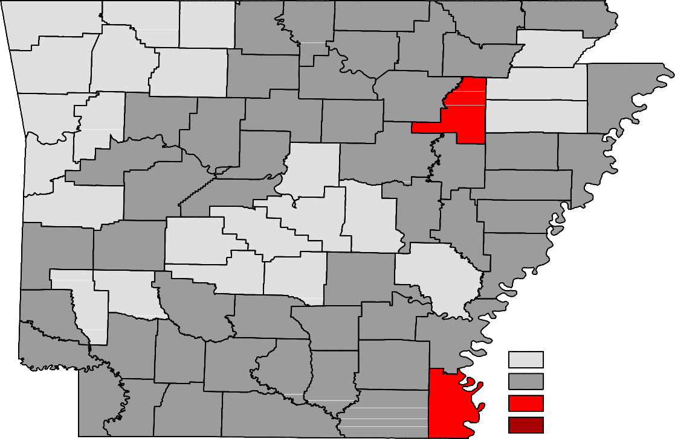
Benton
Carroll
Fulton
Clay
Boone
Randolph
Marion
Baxter
Sharp
Izard
Greene
Madison
Washington
Lawrence
Newton
Searcy
Stone
Independence
Craighead
Mississippi
Crawford
Johnson
Van Buren
Jackson
Poinsett
Franklin
Cleburne
Pope
Conway
Cross
Sebastian
Logan
White
Crittenden
Faulkner
Woodruff
Yell
St. Francis
Perry
Scott
Prairie
Pulaski Lonoke
Lee
Saline
Monroe
Montgomery
Garland
Polk
Phillips
Howard
Hot Spring
Grant
Jefferson
Arkansas
Pike
Sevier
Clark
Dallas
Lincoln
Cleveland
Desha
Little River Hempstead
Nevada
Ouachita
Calhoun
Drew
Bradley
Miller
Lafayette Columbia
Chicot
Union
Ashley
Unemployment Rates
< or = 3.0% 3.1% - 5.0%
5.1% - 7.0%
> 7.0% [NONE]

Ranked by Unemployment Rates
April 2019 (Not Seasonally Adjusted)

Rank  1 | County  Washington | Rate  1.9 | Rank  24 | County  Yell | Rate  3.1 | Rank  48 | County  Lafayette | Rate  3.7
2 | Madison | 2.0 | 27 | Baxter | 3.2 | 48 | Lincoln | 3.7
3 | Benton | 2.1 | 27 | Logan | 3.2 | 48 | Searcy | 3.7
4 | Craighead | 2.3 | 27 | Polk | 3.2 | 54 | Dallas | 3.8
4 | Saline | 2.3 | 30 | Clark | 3.3 | 54 | Johnson | 3.8
6 | Faulkner | 2.4 | 30 | Cleveland | 3.3 | 56 | Conway | 3.9
6 | Lonoke | 2.4 | 30 | Fulton | 3.3 | 56 | Montgomery | 3.9
8 | Grant | 2.5 | 30 | Lawrence | 3.3 | 56 | Sevier | 3.9
8 | Howard | 2.5 | 30 | Lee | 3.3 | 56 | Stone | 3.9
10 | Boone | 2.6 | 30 | Pope | 3.3 | 56 | White | 3.9
10 | Carroll | 2.6 | 36 | Hempstead | 3.4 | 61 | Clay | 4.0
10 | Franklin | 2.6 | 36 | Marion | 3.4 | 61 | Mississippi | 4.0
10 | Greene | 2.6 | 36 | Miller | 3.4 | 61 | Van Buren | 4.0
10 | Poinsett | 2.6 | 36 | Monroe | 3.4 | 64 | Calhoun | 4.1
10 | Scott | 2.6 | 40 | Columbia | 3.5 | 65 | Union | 4.3
10 | Sebastian | 2.6 | 40 | Crittenden | 3.5 | 66 | Jefferson | 4.5
17 | Arkansas | 2.7 | 40 | Little River | 3.5 | 66 | St. Francis | 4.5
17 | Crawford | 2.7 | 40 | Prairie | 3.5 | 68 | Ouachita | 4.6
19 | Pulaski | 2.8 | 44 | Cross | 3.6 | 69 | Drew | 4.7
20 | Garland | 2.9 | 44 | Nevada | 3.6 | 69 | Izard | 4.7
20 | Hot Spring | 2.9 | 44 | Perry | 3.6 | 69 | Phillips | 4.7
20 | Newton | 2.9 | 44 | Sharp | 3.6 | 72 | Ashley | 4.8
20 | Pike | 2.9 | 48 | Bradley | 3.7 | 72 | Woodruff | 4.8
24 | Independence | 3.1 | 48 | Cleburne | 3.7 | 74 | Jackson | 5.2
24 | Randolph | 3.1 | 48 | Desha | 3.7 | 75 | Chicot | 6.4

Local Workforce Development Areas
Civilian Labor Force Estimates
Not Seasonally Adjusted
LWDA
April 2019
CLF Emp Unemp Rate
March 2019
CLF Emp Unemp Rate
April 2018
CLF Emp Unemp Rate

Central (minus LR) | 251,983 | 245,480 | 6,503 | 2.6 | 252,289 | 244,513 | 7,776 | 3.1 | 250,215 | 242,547 | 7,668 | 3.1
City of Little Rock | 97,833 | 95,129 | 2,704 | 2.8 | 97,989 | 94,862 | 3,127 | 3.2 | 97,261 | 93,991 | 3,270 | 3.4
Eastern | 46,615 | 44,823 | 1,792 | 3.8 | 46,459 | 44,325 | 2,134 | 4.6 | 46,627 | 44,630 | 1,997 | 4.3
North Central | 94,578 | 90,934 | 3,644 | 3.9 | 94,495 | 90,152 | 4,343 | 4.6 | 93,829 | 89,937 | 3,892 | 4.1
Northeast | 121,853 | 118,471 | 3,382 | 2.8 | 121,416 | 117,309 | 4,107 | 3.4 | 120,882 | 116,899 | 3,983 | 3.3
Northwest | 326,216 | 319,128 | 7,088 | 2.2 | 326,026 | 317,406 | 8,620 | 2.6 | 322,407 | 313,902 | 8,505 | 2.6
Southeast | 81,459 | 78,171 | 3,288 | 4.0 | 81,366 | 77,508 | 3,858 | 4.7 | 80,745 | 77,261 | 3,484 | 4.3
Southwest | 93,213 | 89,729 | 3,484 | 3.7 | 93,195 | 89,127 | 4,068 | 4.4 | 92,291 | 88,458 | 3,833 | 4.2
West Central | 133,408 | 129,133 | 4,275 | 3.2 | 132,799 | 127,783 | 5,016 | 3.8 | 132,498 | 127,742 | 4,756 | 3.6
Western | 112,299 | 109,274 | 3,025 | 2.7 | 111,677 | 108,048 | 3,629 | 3.2 | 112,936 | 109,072 | 3,864 | 3.4

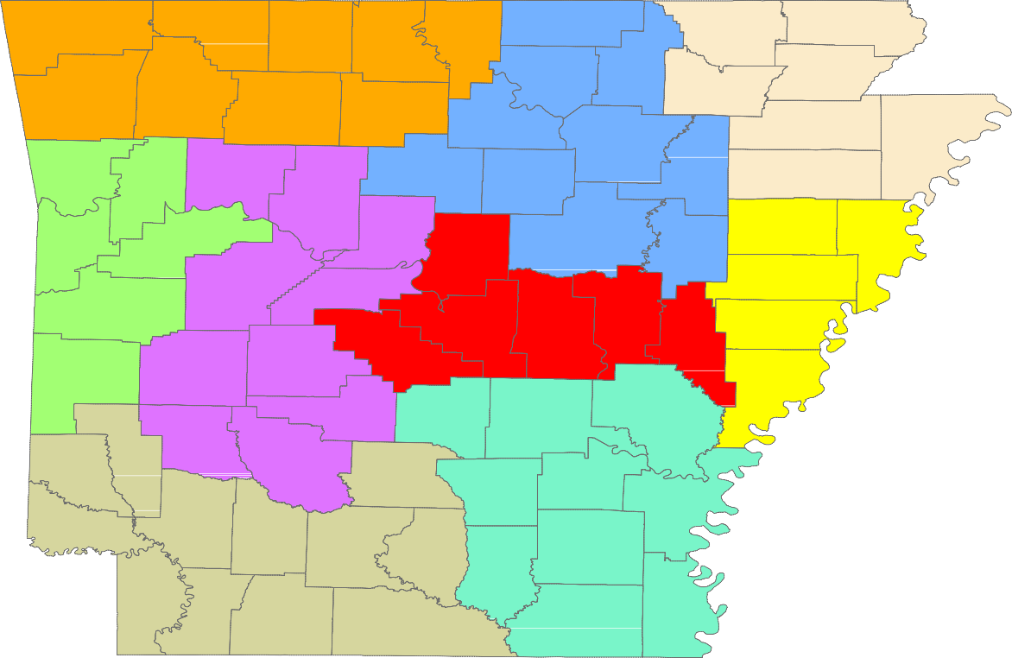
Benton
Carroll
Fulton
Clay
Boone
Randolph
Marion
Baxter
Sharp
Izard
Greene
Madison
Washington
Lawrence
Newton
Searcy
Stone
Craighead
Mississippi
Independence
Crawford
Johnson
Van Buren
Jackson
Franklin
Cleburne
Poinsett
Pope
Conway
Cross
Sebastian
Logan
White
Crittenden
Faulkner
Woodruff
Yell
St. Francis
Perry
Scott
Prairie
Pulaski Lonoke
Lee
Saline
Monroe
Montgomery
Garland
Polk
Phillips
Hot Spring
Grant
Jefferson
Arkansas
Pike
Howard
Clark
Sevier
Dallas
Lincoln
Cleveland
Desha
Little River Hempstead
Nevada
Ouachita
Calhoun
Drew
Bradley
Miller
Columbia
Chicot
Union
Ashley
Lafayette

Central (minus LR) Eastern
North Central
Northeast Northwest Southeast
Southwest West Central Western

www.discover.arkansas.gov
18

