Arkansas
Labor Market
Report

August 2016

Table of Contents

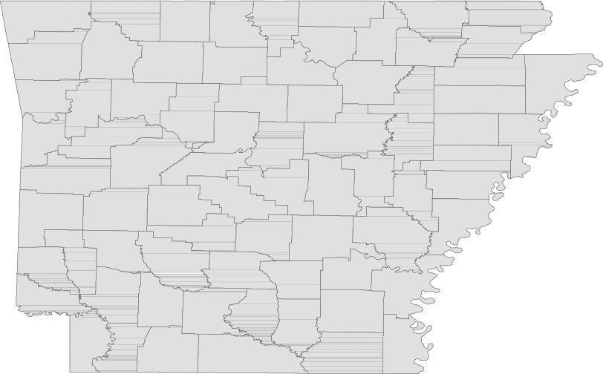Monthly Spotlight..................................................2

Arkansas Labor Force Summary.......................3

Arkansas Nonfarm Payroll Jobs........................4

Arkansas Production Workers...........................6

Metropolitan Statistical Areas...........................7

Micropolitan Statistical Areas/Cities.............14

County Labor Force Statistics..........................15

Local Workforce Development Areas..........18

Technical Notes

The Arkansas Labor Market is prepared monthly in conjunction with the U.S. Department of Labor, Bu- reau of Labor Statistics (BLS). The current month’s estimates are preliminary, while previous data are subject to revision.

Estimates of nonfarm payroll jobs show the num- ber of jobs by industry and reflect employment by place of work. Hours and earnings estimates are based on payroll and worker-hour data col- lected for production workers in manufacturing industries.

Industries are classified according to the North American Industry Classification System (NAICS). All estimates are based on a first quarter 2015 benchmark.

Explanation of Terms and Concepts

Monthly Business Survey of Employers

A monthly sample survey designed to provide industry information on nonfarm payroll jobs. Data are compiled each month from mail surveys and telephone interviews conducted by the Bureau of Labor Statistics in cooperation with Department of Workforce Services. The data are based on establishment records and include all workers, full-or part-time, who received pay during the payroll period which includes the 12th of the
month. Approximately 5,000 Arkansas business
establishments are surveyed.

Metropolitan Statistical Area (MSA)

A term applied by the U.S. Office of Management and Budget to counties that have one or more central cities and that meet specified criteria of population density, commuting patterns and social and economic integration.

Current Population Survey (CPS)

A monthly sample survey of the population 16 years of age and over, designed to provide data on the labor force, the employed and the unem- ployed. The survey is conducted each month by the Bureau of the Census for BLS. The information is collected by trained interviewers from a sample of about 60,000 households. The data collected are based on the activity reported for the calendar week including the 12th of the month. Approxi- mately 800 Arkansas households are represented in the sample survey.

Civilian Labor Force

The sum of all employed and unemployed persons
16 years of age or older. Members of the Armed
Forces are excluded.
Employment

An estimate of the number of persons who worked any time for pay or profit or worked 15 hours or more as unpaid workers in a family business dur- ing the calendar week which includes the 12th of the month. Also included are those who, although not working, had some job attachment and were not looking for work, and persons involved in labor management disputes.

Unemployment

An estimate of the number of persons who did not have a job, but were available for work and actively seeking work during the calendar week which includes the 12th of the month.

Unemployment Rate

The number of unemployed as a percentage of the civilian labor force. Unemployment rates are calculated from unrounded data.

Seasonal Adjustment

A statistical technique applied to monthly data to eliminate changes that normally occur during the year due to seasonal events such as weather, major holidays, schedule shifts, harvest times, and the opening/closing of schools.

August Spotlight
Seasonal Employment Trends (Par t 2 of 2)

As discussed in the July Labor Market Report, employment in some major industry sectors is directly influenced by seasonal trends. When employment from multiple years is compared, these patterns become apparent. Sea- sonal trends are related to set schedules of operation, holidays, and weather patterns. Last month’s Spotlight discussed the seasonal trends seen in state and local government, educational services, and leisure and hospi- tality. In this issue, the seasonality of construction and professional-scientific-technical services is highlighted, along with some of the industries that are indirectly affected by seasonal movements.

Employment in the construction sector is sig- nificantly affected by weather patterns. While construction operations run year round, more projects are commissioned during the spring and summer than in the winter. In general, employ- ment in construction begins to increase in March, often peaks around July or August, and then tends to decline in September or October (see Chart 4). These weather patterns are a generalization, as non-typical weather events will also influence jobs in construction. On the other hand, large scale projects can cause employment spikes that are unrelated to the weather.

Found under the professional and business ser- vices sector, the professional-scientific-technical services subsector includes a particular type of business that is highly seasonal-- accounting and tax preparation services. Seasonal hiring related

54,000

52,000

50,000

48,000

46,000

44,000

42,000

40,000
Chart 4. Employment in Construction
January 2014 - August 2016

J F M A M J J A S O N D
2014 2015 2016

to tax preparation typically begins in November or December, with employment in the subsector peaking from
February to April. Employment tends to remain fairly constant throughout the summer and fall months. While
this seasonal trend is significant, employment in accounting and tax preparation is not large enough to affect the
trend of the professional and business services sector as a whole.

There are also other seasonal businesses, many of which may not be visible when tracking the movement of the major industry sector. For example, landscaping services is influenced by weather and the seasons. Em- ployment in landscaping services increases during the spring and summer months, but the number of workers is not large enough to impact the movement of the administrative and support services subsector as a whole. Similarly, employment in other services to buildings and dwellings (also under the administrative and support services subsector) tends to increase in the spring and summer. This includes activities such as cleaning swim- ming pools, driveways, and gutters and power-washing building exteriors.

It is important to keep in mind that some other industries are indirectly affected by these seasonal employment fluctuations. The timber industry, for example, relies heavily on the construction sector and may experience declines and increases in employment related to construction patterns. Similarly, movement within the retail trade sector will affect both wholesale trade and the transportation of goods. Some industries are indirectly affected by school closures in the summer. Employment in day care services (found under the social assistance subsector) increases in the summer when schools are closed, as does employment at businesses such as day camps and summer sports programs. There are also many non-profit organizations (under Other Services) with activities designed for children during the summer months.

Civilian Labor Force Summar y

Labor force data, produced by the U.S. Department of Labor, Bureau of Labor Statistics and released by the Arkansas Department of Workforce Services, show Arkansas’ seasonally adjusted unemployment rate remained stable between July and August at 3.9 percent. Arkansas’ civilian labor force declined
1,520, a result of 1,787 fewer employed and 267 more unemployed Arkansans. At 4.9 percent, the
United States’ jobless rate was unchanged over the month.

BLS Program Operations Manager Susan Price said, “The unemployment rate in Arkansas remained stable this month, as did the national unemployment rate. While jobless rates in Arkansas and the U.S. were both at 5.1 percent in August 2015, Arkansas has declined at a faster pace. We are now one full percentage point lower than the national rate.”

Civilian Labor Force Estimates

Seasonally Adjusted Not Seasonally Adjusted

Civilian Labor Force | Aug 16  1,355,931 | Jul 16  1,357,451 | Aug 15  1,331,901 | Civilian Labor Force | Aug 16  1,351,630 | Jul 16  1,369,163 | Aug 15  1,334,052
Employment | 1,302,761 | 1,304,548 | 1,264,414 | Employment | 1,299,864 | 1,309,896 | 1,268,523
Unemployment | 53,170 | 52,903 | 67,487 | Unemployment | 51,766 | 59,267 | 65,529
Unemployment Rate | 3.9 | 3.9 | 5.1 | Unemployment Rate | 3.8 | 4.3 | 4.9
U.S. Unemployment | 4.9 | 4.9 | 5.1 | U.S. Unemployment | 5.0 | 5.1 | 5.2

5.5
Unemployment Rates (Seasonally Adjusted) State of Arkansas vs. United States August 2015 - August 2016

5.0

4.5

4.0

3.5

3.0

Aug '15 Oct '15 Dec '15 Feb '16 Apr '16 Jun '16 Aug '16
State of Arkansas United States

Nonfarm Payroll Jobs

Not Seasonally Adjusted
(In Thousands)

(NAICS)
Aug 16 Jul 16 Aug 15
OTM OT Y

Total Nonfarm | 1220.0 | 1215.0 | 1203.1 | 5.0 | 16.9
Goods Producing | 210.6 | 211.4 | 213.9 | -0.8 | -3.3
Mining, Logging, and Construction | 57.6 | 57.8 | 59.1 | -0.2 | -1.5
Mining & Logging 6.5 6.7 7.8 -0.2 -1.3
Construction | 51.1 | 51.1 | 51.3 | 0.0 | -0.2
Specialty Trade Contractors | 34.2 | 33.8 | 31.9 | 0.4 | 2.3
Manufacturing | 153.0 | 153.6 | 154.8 | -0.6 | -1.8
Durable Goods | 73.6 | 73.5 | 75.9 | 0.1 | -2.3
Nondurable Goods | 79.4 | 80.1 | 78.9 | -0.7 | 0.5
Service Providing | 1009.4 | 1003.6 | 989.2 | 5.8 | 20.2
Trade, Transportation & Utilities | 256.8 | 255.3 | 253.4 | 1.5 | 3.4
Wholesale Trade | 49.0 | 48.5 | 47.6 | 0.5 | 1.4
Retail Trade | 143.8 | 143.1 | 141.6 | 0.7 | 2.2
Transport, Warehousing & Utilities | 64.0 | 63.7 | 64.2 | 0.3 | -0.2
Information | 13.8 | 13.9 | 13.4 | -0.1 | 0.4
Financial Activities | 49.8 | 50.0 | 49.7 | -0.2 | 0.1
Finance & Insurance | 36.6 | 36.8 | 36.3 | -0.2 | 0.3
Real Estate & Rental & Leasing | 13.2 | 13.2 | 13.4 | 0.0 | -0.2
Professional & Business Services | 145.1 | 145.2 | 137.5 | -0.1 | 7.6
Professional, Scientific & Technical | 42.9 | 43.7 | 40.6 | -0.8 | 2.3
Management of Companies | 35.3 | 35.1 | 33.8 | 0.2 | 1.5
Administrative & Support Services | 66.9 | 66.4 | 63.1 | 0.5 | 3.8
Educational & Health Services | 180.6 | 179.2 | 174.2 | 1.4 | 6.4
Educational Services | 12.6 | 12.1 | 12.0 | 0.5 | 0.6
Health Care & Social Assistance | 168.0 | 167.1 | 162.2 | 0.9 | 5.8
Ambulatory Health Care | 52.9 | 53.3 | 51.5 | -0.4 | 1.4
Social Assistance | 40.1 | 39.0 | 38.6 | 1.1 | 1.5
Leisure & Hospitality 116.7 116.0 115.1 0.7 1.6
Arts, Entertainment & Recreation | 12.2 | 12.4 | 12.1 | -0.2 | 0.1
Accommodation & Food Services | 104.5 | 103.6 | 103.0 | 0.9 | 1.5
Accommodation Services | 12.0 | 12.3 | 11.6 | -0.3 | 0.4
Food Services | 92.5 | 91.3 | 91.4 | 1.2 | 1.1
Other Services | 44.4 | 45.0 | 44.0 | -0.6 | 0.4
Government | 202.2 | 199.0 | 201.9 | 3.2 | 0.3
Federal Government | 20.6 | 20.6 | 20.3 | 0.0 | 0.3
State Government | 75.0 | 73.4 | 74.4 | 1.6 | 0.6
Local Government | 106.6 | 105.0 | 107.2 | 1.6 | -0.6

Nonfarm Payroll Job Summar y

July 2016 - August 2016

Arkansas’ nonfarm payroll employment rose 5,000 in August to total 1,220,000. Jobs in four major in- dustry sectors increased, more than offsetting minor declines in six sectors. Government added 3,200 jobs. Gains in state (+1,600) and local (+1,600) government were related to the start of the 2016-2017 school year. Employment in trade, transportation, and utilities rose 1,500. Seasonal hiring was re- ported across all three subsectors. Employment in educational and health services increased 1,400. Typical expansions occurred in both health care and social assistance (+900) and in educational services (+500).

August 2015 - August 2016

Compared to August 2015, nonfarm payroll jobs in Arkansas are up 16,900. Eight major industry sec- tors posted growth, while employment in three sectors declined. Jobs in professional and business services increased 7,600. The majority of the hiring was reported in administrative and support services (+3,800), a subsector that includes employment agencies. Educational and health services added
6,400 jobs, mostly in health care and social assistance (+5,800). Employment in trade, transportation, and utilities rose 3,400. Most of the gains were in retail trade (+2,200). Jobs in leisure and hospital- ity increased 1,600. Expansions in accommodation and food services accounted for a majority of the growth. Employment in manufacturing decreased 1,800. Losses in durable goods (-2,300) offset the gains in nondurable goods (+500). Mining and logging declined 1,300, due to layoffs and closures.

1,250,000
Nonfarm Payroll Jobs (Not Seasonally Adjusted)
August: 1996 - 2016

1,200,000

1,150,000

1,100,000

1,050,000

1,000,000

'96 '97 '98 '99 '00 '01 '02 '03 '04 '05 '06 '07 '08 '09 '10 '11 '12 '13 '14 '15 '16

Production Workers- Hours and Earnings

Manufacturing

Aug 16 Jul 16
Aug 15

Average Weekly Hours Average Hourly Earnings Average Weekly Earnings

41.3
15.66
646.76

40.5
15.76
638.28

41.5
16.29
676.04

Durable Goods and Nondurable Goods Manufacturing

Durable Goods Manufacturing Nondurable Goods Manufacturing

Aug 16 Jul 16

Aug 15

Aug 16 Jul 16
Aug 15

Average Weekly Hours Average Hourly Earnings Average Weekly Earnings

42.6
17.41
741.67

41.0
17.68
724.88

40.9
17.88
731.29

Average Weekly Hours Average Hourly Earnings Average Weekly Earnings

40.0
13.92
556.80
40.1
13.93
558.59
42.1
14.80
623.08

800.00
Average Weekly Earnings: Durable Goods vs. Nondurable Goods
August: 2006 - 2016

750.00

700.00

650.00

600.00

550.00

500.00

450.00

400.00

350.00

300.00

'06 '07 '08 '09 '10 '11 '12 '13 '14 '15 '16
Durable Goods Nondurable Goods

Little Rock-Nor th Little Rock-Conway MSA

The Little Rock-North Little Rock-Conway MSA= Faulkner, Grant, Lonoke, Perry, Pulaski, & Saline counties.

Civilian Labor Force Estimates (Not Seasonally Adjusted)

 | Aug 16 | Jul 16 | Aug 15 | OTM | OT Y
Civilian Labor Force | 356,084 | 363,885 | 351,682 | -7,801 | 4,402
Employment | 343,946 | 350,111 | 336,299 | -6,165 | 7,647
Unemployment | 12,138 | 13,774 | 15,383 | -1,636 | -3,245
Unemployment Rate | 3.4 | 3.8 | 4.4 | -0.4 | -1.0

Nonfarm Payroll Jobs (Not Seasonally Adjusted)
(In Thousands)

NAICS  Total Nonfarm | Aug 16  355.1 | Jul 16  354.1 | Aug 15  350.6 | OTM  1.0 | OT Y  4.5
Goods Producing | 37.0 | 36.9 | 37.7 | 0.1 | -0.7
Mining, Logging & Construction | 16.7 | 16.5 | 17.4 | 0.2 | -0.7
Manufacturing | 20.3 | 20.4 | 20.3 | -0.1 | 0.0
Service Providing 318.1 317.2 312.9 0.9 5.2
Trade, Transportation & Utilities | 70.4 | 69.8 | 69.1 | 0.6 | 1.3
Wholesale Trade | 15.3 | 15.3 | 15.3 | 0.0 | 0.0
Retail Trade | 40.3 | 39.7 | 39.3 | 0.6 | 1.0
Trans., Warehousing & Utilities | 14.8 | 14.8 | 14.5 | 0.0 | 0.3
Information | 6.2 | 6.2 | 6.4 | 0.0 | -0.2
Financial Activities | 20.8 | 20.8 | 20.8 | 0.0 | 0.0
Professional & Business Services | 48.9 | 48.8 | 46.4 | 0.1 | 2.5
Educational & Health Services | 53.1 | 53.4 | 52.0 | -0.3 | 1.1
Leisure & Hospitality | 34.1 | 34.4 | 34.0 | -0.3 | 0.1
Other Services | 15.4 | 15.6 | 15.3 | -0.2 | 0.1
Government | 69.2 | 68.2 | 68.9 | 1.0 | 0.3
Federal Government | 9.8 | 9.8 | 9.7 | 0.0 | 0.1
State Government | 34.1 | 33.5 | 33.7 | 0.6 | 0.4
Local Government | 25.3 | 24.9 | 25.5 | 0.4 | -0.2

350,000
Number of Employed
August: 2006 - 2016

74,000
Jobs in Trade, Transportation, and Utilities
January 2014 - August 2016

345,000

72,000

340,000

335,000
70,000

330,000

68,000

325,000

320,000

66,000

315,000

64,000

310,000

305,000

'06 '07 '08 '09 '10 '11 '12 '13 '14 '15 '16
62,000

J F M A M J J A S O N D
2014 2015 2016

Fayetteville-Springdale-Rogers MSA

The Fayetteville-Springdale-Rogers MSA= Benton, Madison, & Washington counties in Arkansas & McDonald county in Missouri.

Civilian Labor Force Estimates (Not Seasonally Adjusted)

 | Aug 16 | Jul 16 | Aug 15 | OTM | OT Y
Civilian Labor Force | 262,910 | 268,347 | 254,914 | -5,437 | 7,996
Employment | 255,574 | 259,899 | 246,009 | -4,325 | 9,565
Unemployment | 7,336 | 8,448 | 8,905 | -1,112 | -1,569
Unemployment Rate | 2.8 | 3.1 | 3.5 | -0.3 | -0.7

Nonfarm Payroll Jobs (Not Seasonally Adjusted)
(In Thousands)

NAICS  Total Nonfarm | Aug 16  241.2 | Jul 16  240.9 | Aug 15  234.3 | OTM  0.3 | OT Y  6.9
Goods Producing | 36.6 | 36.9 | 37.1 | -0.3 | -0.5
Mining, Logging & Construction | 10.5 | 10.6 | 10.0 | -0.1 | 0.5
Manufacturing | 26.1 | 26.3 | 27.1 | -0.2 | -1.0
Service Providing 204.6 204.0 197.2 0.6 7.4
Trade, Transportation & Utilities | 55.5 | 55.3 | 54.2 | 0.2 | 1.3
Wholesale Trade | 12.3 | 12.3 | 11.9 | 0.0 | 0.4
Retail Trade | 26.7 | 26.6 | 26.1 | 0.1 | 0.6
Trans., Warehousing & Utilities | 16.5 | 16.4 | 16.2 | 0.1 | 0.3
Information | 2.0 | 2.0 | 2.0 | 0.0 | 0.0
Financial Activities | 7.0 | 7.0 | 6.9 | 0.0 | 0.1
Professional & Business Services | 50.4 | 50.9 | 47.0 | -0.5 | 3.4
Educational & Health Services | 26.4 | 26.2 | 25.3 | 0.2 | 1.1
Leisure & Hospitality | 24.5 | 24.6 | 24.1 | -0.1 | 0.4
Other Services | 7.4 | 7.4 | 7.2 | 0.0 | 0.2
Government | 31.4 | 30.6 | 30.5 | 0.8 | 0.9
Federal Government | 2.6 | 2.6 | 2.6 | 0.0 | 0.0
State Government | 11.9 | 11.2 | 11.3 | 0.7 | 0.6
Local Government | 16.9 | 16.8 | 16.6 | 0.1 | 0.3

55,000
Jobs in Professional and Business Services
August: 1996 - 2016

50,000

45,000

40,000

35,000

30,000

25,000

20,000

15,000

10,000

'96 '97 '98 '99 '00 '01 '02 '03 '04 '05 '06 '07 '08 '09 '10 '11 '12 '13 '14 '15 '16

For t Smith MSA

The Fort Smith MSA= Crawford & Sebastian counties in Arkansas & LeFlore & Sequoyah counties in Oklahoma.

Civilian Labor Force Estimates (Not Seasonally Adjusted)

 | Aug 16 | Jul 16 | Aug 15 | OTM | OT Y
Civilian Labor Force | 121,477 | 122,874 | 121,317 | -1,397 | 160
Employment | 115,858 | 116,749 | 114,988 | -891 | 870
Unemployment | 5,619 | 6,125 | 6,329 | -506 | -710
Unemployment Rate | 4.6 | 5.0 | 5.2 | -0.4 | -0.6

Nonfarm Payroll Jobs (Not Seasonally Adjusted)
(In Thousands)

NAICS  Total Nonfarm | Aug 16  113.0 | Jul 16  111.7 | Aug 15  112.4 | OTM  1.3 | OT Y  0.6
Goods Producing | 23.6 | 23.7 | 23.8 | -0.1 | -0.2
Mining, Logging & Construction | 5.7 | 5.8 | 6.1 | -0.1 | -0.4
Manufacturing | 17.9 | 17.9 | 17.7 | 0.0 | 0.2
Service Providing 89.4 88.0 88.6 1.4 0.8
Trade, Transportation & Utilities | 24.0 | 23.7 | 23.8 | 0.3 | 0.2
Wholesale Trade | 4.4 | 4.3 | 4.2 | 0.1 | 0.2
Retail Trade | 13.0 | 12.8 | 12.8 | 0.2 | 0.2
Trans., Warehousing & Utilities | 6.6 | 6.6 | 6.8 | 0.0 | -0.2
Information | 1.2 | 1.2 | 1.2 | 0.0 | 0.0
Financial Activities | 3.7 | 3.7 | 3.8 | 0.0 | -0.1
Professional & Business Services | 12.2 | 12.1 | 12.1 | 0.1 | 0.1
Educational & Health Services | 16.6 | 16.7 | 16.6 | -0.1 | 0.0
Leisure & Hospitality | 9.8 | 9.8 | 9.6 | 0.0 | 0.2
Other Services | 4.3 | 4.4 | 4.3 | -0.1 | 0.0
Government | 17.6 | 16.4 | 17.2 | 1.2 | 0.4
Federal Government | 1.4 | 1.4 | 1.3 | 0.0 | 0.1
State Government | 2.9 | 2.9 | 2.9 | 0.0 | 0.0
Local Government | 13.3 | 12.1 | 13.0 | 1.2 | 0.3
Nonfarm Payroll Jobs by Industry (Percent of Total)
August 2016
Mining-Logging-Construction
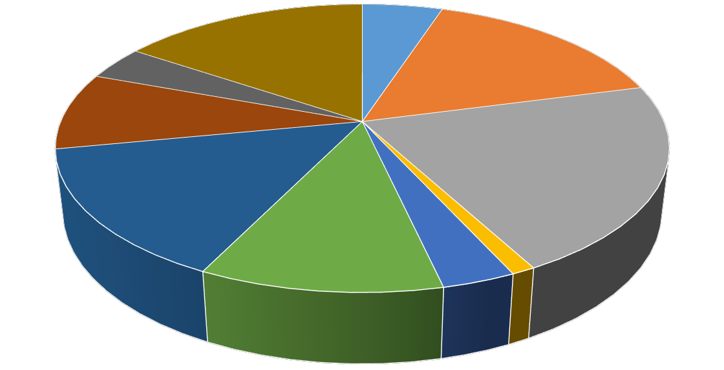5.0%

Other Services
3.8%

Leisure & Hospitality
8.7%

Education & Health
Services
14.7%
Government
15.6%

Professional &
Business Services
10.8%

Manufacturing
15.8%

Trade-Transportation- Utilities
21.2%

Information

Financial Activities
3.3%
1.1%

Hot Springs MSA

The Hot Springs MSA= Garland County.

Civilian Labor Force Estimates (Not Seasonally Adjusted)

 | Aug 16 | Jul 16 | Aug 15 | OTM | OT Y
Civilian Labor Force | 41,200 | 42,401 | 40,737 | -1,201 | 463
Employment | 39,537 | 40,471 | 38,568 | -934 | 969
Unemployment | 1,663 | 1,930 | 2,169 | -267 | -506
Unemployment Rate | 4.0 | 4.6 | 5.3 | -0.6 | -1.3

Nonfarm Payroll Jobs (Not Seasonally Adjusted)
(In Thousands)

NAICS
Aug 16 | Jul 16 | Aug 15 | OTM | OT Y
38.3 | 38.4 | 37.7 | -0.1 | 0.6
4.5 | 4.5 | 4.5 | 0.0 | 0.0
33.8 | 33.9 | 33.2 | -0.1 | 0.6
4.5 | 4.2 | 4.5 | 0.3 | 0.0

Total Nonfarm Goods Producing Service Providing Government

39,500
Nonfarm Payroll Jobs
August 2014 - August 2016

39,000

38,500

38,000

37,500

37,000

36,500

36,000

Aug '14 Nov '14 Feb '15 May '15 Aug '15 Nov '15 Feb '16 May '16 Aug '16

Jonesboro MSA

The Jonesboro MSA= Craighead & Poinsett counties.

Civilian Labor Force Estimates (Not Seasonally Adjusted)

 | Aug 16 | Jul 16 | Aug 15 | OTM | OT Y
Civilian Labor Force | 63,188 | 64,170 | 61,237 | -982 | 1,951
Employment | 61,122 | 61,786 | 58,528 | -664 | 2,594
Unemployment | 2,066 | 2,384 | 2,709 | -318 | -643
Unemployment Rate | 3.3 | 3.7 | 4.4 | -0.4 | -1.1

Nonfarm Payroll Jobs (Not Seasonally Adjusted)
(In Thousands)

NAICS
Aug 16 | Jul 16 | Aug 15 | OTM | OT Y
55.9 | 55.5 | 54.1 | 0.4 | 1.8
9.2 | 9.2 | 8.9 | 0.0 | 0.3
46.7 | 46.3 | 45.2 | 0.4 | 1.5
8.5 | 8.4 | 8.4 | 0.1 | 0.1

Total Nonfarm Goods Producing Service Providing Government

62,000
Number of Employed
August: 2006 - 2016

60,000

58,000

56,000

54,000

52,000

50,000

48,000

'06 '07 '08 '09 '10 '11 '12 '13 '14 '15 '16

Pine Bluff MSA

The Pine Bluff MSA= Cleveland, Jefferson, & Lincoln counties.

Civilian Labor Force Estimates (Not Seasonally Adjusted)

 | Aug 16 | Jul 16 | Aug 15 | OTM | OT Y
Civilian Labor Force | 36,172 | 36,817 | 36,669 | -645 | -497
Employment | 34,142 | 34,604 | 34,146 | -462 | -4
Unemployment | 2,030 | 2,213 | 2,523 | -183 | -493
Unemployment Rate | 5.6 | 6.0 | 6.9 | -0.4 | -1.3

Nonfarm Payroll Jobs (Not Seasonally Adjusted)
(In Thousands)

NAICS
Aug 16 | Jul 16 | Aug 15 | OTM | OT Y
32.9 | 32.8 | 33.4 | 0.1 | -0.5
5.9 | 5.9 | 6.2 | 0.0 | -0.3
27.0 | 26.9 | 27.2 | 0.1 | -0.2
9.0 | 8.9 | 9.2 | 0.1 | -0.2

Total Nonfarm Goods Producing Service Providing Government

35,000
Nonfarm Payroll Jobs
January 2014 - August 2016

34,500

34,000

33,500

33,000

32,500

32,000

31,500

J F M A M J J A S O N D

2014 2015 2016

Out-of-State MSA

Civilian Labor Force Estimates (Not Seasonally Adjusted)

Memphis, TN-MS-AR MSA

The Memphis, TN-MS-AR MSA= Fayette, Shelby, & Tipton counties in Tennessee; Benton, Desoto, Marshall, Tate, & Tunica counties in Mississippi; & Crittenden County in Arkansas.

 | Aug 16 | Jul 16 | Aug 15 | OTM | OT Y
Civilian Labor Force | 624,425 | 632,007 | 614,016 | -7,582 | 10,409
Employment | 590,261 | 597,518 | 574,812 | -7,257 | 15,449
Unemployment | 34,164 | 34,489 | 39,204 | -325 | -5,040
Unemployment Rate | 5.5 | 5.5 | 6.4 | 0.0 | -0.9

Texarkana MSA

The Texarkana MSA= Bowie County in Texas & Little River & Miller counties in Arkansas.

 | Aug 16 | Jul 16 | Aug 15 | OTM | OT Y
Civilian Labor Force | 64,852 | 65,180 | 64,458 | -328 | 394
Employment | 61,642 | 61,783 | 61,273 | -141 | 369
Unemployment | 3,210 | 3,397 | 3,185 | -187 | 25
Unemployment Rate | 4.9 | 5.2 | 4.9 | -0.3 | 0.0

610,000
Number of Employed- Memphis MSA
January 2014 - August 2016

9.0
Unemployment Rates- Texarkana MSA
August: 2006 - 2016

600,000
8.0

590,000

7.0

6.0

580,000

5.0

570,000
4.0

560,000
3.0

550,000
2.0

1.0

540,000

J F M A M J J A S O N D
2014 2015 2016

0.0

'06 '07 '08 '09 '10 '11 '12 '13 '14 '15 '16

Micropolitan Labor Force Estimates (Not Seasonally Adjusted)

August 2016 July 2016 August 2015

Micro Area  Arkadelphia Micro | CLF  9,666 | Emp  9,241 | Unemp  425 | Rate  4.4 | CLF  9,540 | Emp  9,037 | Unemp  503 | Rate  5.3 | CLF  9,423 | Emp  8,890 | Unemp  533 | Rate  5.7
Batesville Micro | 15,716 | 14,937 | 779 | 5.0 | 15,923 | 15,047 | 876 | 5.5 | 15,369 | 14,319 | 1,050 | 6.8
Blytheville Micro | 17,777 | 16,500 | 1,277 | 7.2 | 17,806 | 16,474 | 1,332 | 7.5 | 18,352 | 16,586 | 1,766 | 9.6
Camden Micro | 12,357 | 11,684 | 673 | 5.4 | 12,532 | 11,811 | 721 | 5.8 | 12,187 | 11,471 | 716 | 5.9
El Dorado Micro | 17,351 | 16,396 | 955 | 5.5 | 17,520 | 16,478 | 1,042 | 5.9 | 17,104 | 16,043 | 1,061 | 6.2
Forrest City Micro | 8,947 | 8,496 | 451 | 5.0 | 8,777 | 8,291 | 486 | 5.5 | 9,028 | 8,334 | 694 | 7.7
Harrison Micro | 18,993 | 18,364 | 629 | 3.3 | 19,014 | 18,250 | 764 | 4.0 | 19,195 | 18,321 | 874 | 4.6
Helena-West Helena Micro | 6,853 | 6,482 | 371 | 5.4 | 6,705 | 6,285 | 420 | 6.3 | 6,915 | 6,404 | 511 | 7.4
Magnolia Micro | 9,396 | 8,866 | 530 | 5.6 | 9,259 | 8,661 | 598 | 6.5 | 9,386 | 8,739 | 647 | 6.9
Malvern Micro | 14,347 | 13,832 | 515 | 3.6 | 14,558 | 13,921 | 637 | 4.4 | 14,310 | 13,621 | 689 | 4.8
Mountain Home Micro | 16,159 | 15,510 | 649 | 4.0 | 16,243 | 15,496 | 747 | 4.6 | 16,144 | 15,316 | 828 | 5.1
Paragould Micro | 19,744 | 18,964 | 780 | 4.0 | 20,000 | 19,064 | 936 | 4.7 | 19,809 | 18,843 | 966 | 4.9
Russellville Micro | 38,124 | 36,380 | 1,744 | 4.6 | 38,132 | 36,047 | 2,085 | 5.5 | 37,992 | 35,918 | 2,074 | 5.5
Searcy Micro | 34,845 | 33,197 | 1,648 | 4.7 | 34,553 | 32,673 | 1,880 | 5.4 | 34,353 | 32,283 | 2,070 | 6.0

Arkadelphia Micro= Clark County Batesville Micro= Independence County Blytheville Micro= Mississippi County
Camden Micro= Calhoun & Ouachita counties
El Dorado Micro= Union County
Forrest City Micro= St. Francis County Harrison Micro= Boone & Newton counties Helena-West Helena Micro= Phillips County Magnolia Micro= Columbia County
Malvern Micro= Hot Spring County
Mountain Home Micro= Baxter County Paragould Micro= Greene County Russellville Micro= Pope & Yell counties Searcy Micro= White County

City Labor Force Statistics (Not Seasonally Adjusted)

August 2016 July 2016 August 2015

City  Bella Vista | CLF  12,051 | Emp  11,683 | Unemp  368 | Rate  3.1 | CLF  12,344 | Emp  11,887 | Unemp  457 | Rate  3.7 | CLF  11,721 | Emp  11,239 | Unemp  482 | Rate  4.1
Benton | 16,388 | 15,879 | 509 | 3.1 | 16,752 | 16,168 | 584 | 3.5 | 16,174 | 15,534 | 640 | 4.0
Bentonville | 22,539 | 21,959 | 580 | 2.6 | 23,062 | 22,343 | 719 | 3.1 | 21,826 | 21,124 | 702 | 3.2
Blytheville | 6,134 | 5,633 | 501 | 8.2 | 6,124 | 5,625 | 499 | 8.1 | 6,435 | 5,663 | 772 | 12.0
Cabot | 11,911 | 11,546 | 365 | 3.1 | 12,146 | 11,735 | 411 | 3.4 | 11,708 | 11,261 | 447 | 3.8
Conway | 33,464 | 32,331 | 1,133 | 3.4 | 34,189 | 32,906 | 1,283 | 3.8 | 33,036 | 31,611 | 1,425 | 4.3
El Dorado | 7,535 | 7,071 | 464 | 6.2 | 7,620 | 7,106 | 514 | 6.7 | 7,461 | 6,918 | 543 | 7.3
Fayetteville | 45,864 | 44,566 | 1,298 | 2.8 | 46,865 | 45,345 | 1,520 | 3.2 | 44,477 | 42,886 | 1,591 | 3.6
Fort Smith | 40,306 | 38,898 | 1,408 | 3.5 | 40,787 | 39,229 | 1,558 | 3.8 | 40,063 | 38,207 | 1,856 | 4.6
Hot Springs | 14,391 | 13,743 | 648 | 4.5 | 14,823 | 14,068 | 755 | 5.1 | 14,243 | 13,406 | 837 | 5.9
Jacksonville | 12,030 | 11,515 | 515 | 4.3 | 12,323 | 11,725 | 598 | 4.9 | 11,890 | 11,264 | 626 | 5.3
Jonesboro | 36,814 | 35,668 | 1,146 | 3.1 | 37,454 | 36,073 | 1,381 | 3.7 | 35,751 | 34,179 | 1,572 | 4.4
Little Rock | 98,441 | 95,065 | 3,376 | 3.4 | 100,638 | 96,800 | 3,838 | 3.8 | 97,394 | 92,994 | 4,400 | 4.5
North Little Rock | 30,616 | 29,492 | 1,124 | 3.7 | 31,310 | 30,030 | 1,280 | 4.1 | 30,287 | 28,850 | 1,437 | 4.7
Paragould | 12,315 | 11,807 | 508 | 4.1 | 12,508 | 11,870 | 638 | 5.1 | 12,358 | 11,732 | 626 | 5.1
Pine Bluff | 17,335 | 16,145 | 1,190 | 6.9 | 17,681 | 16,377 | 1,304 | 7.4 | 17,665 | 16,175 | 1,490 | 8.4
Rogers | 33,310 | 32,464 | 846 | 2.5 | 33,982 | 33,031 | 951 | 2.8 | 32,359 | 31,230 | 1,129 | 3.5
Russellville | 13,618 | 12,985 | 633 | 4.6 | 13,619 | 12,872 | 747 | 5.5 | 13,577 | 12,841 | 736 | 5.4
Searcy | 10,657 | 10,230 | 427 | 4.0 | 10,567 | 10,069 | 498 | 4.7 | 10,522 | 9,949 | 573 | 5.4
Sherwood | 15,800 | 15,339 | 461 | 2.9 | 16,123 | 15,619 | 504 | 3.1 | 15,578 | 15,004 | 574 | 3.7
Springdale | 38,318 | 37,327 | 991 | 2.6 | 39,129 | 37,980 | 1,149 | 2.9 | 37,093 | 35,919 | 1,174 | 3.2
Texarkana, AR | 13,749 | 13,156 | 593 | 4.3 | 14,072 | 13,336 | 736 | 5.2 | 13,785 | 13,029 | 756 | 5.5
Van Buren | 10,518 | 10,144 | 374 | 3.6 | 10,647 | 10,223 | 424 | 4.0 | 10,457 | 9,949 | 508 | 4.9
West Memphis | 10,917 | 10,356 | 561 | 5.1 | 11,111 | 10,469 | 642 | 5.8 | 10,876 | 10,157 | 719 | 6.6

August 2016 July 2016 August 2015

County  Arkansas | CLF  9,709 | Emp  9,409 | Unemp  300 | Rate  3.1 | CLF  9,797 | Emp  9,451 | Unemp  346 | Rate  3.5 | CLF  9,450 | Emp  9,070 | Unemp  380 | Rate  4.0
Ashley | 8,112 | 7,621 | 491 | 6.1 | 8,109 | 7,579 | 530 | 6.5 | 8,013 | 7,406 | 607 | 7.6
Baxter | 16,159 | 15,510 | 649 | 4.0 | 16,243 | 15,496 | 747 | 4.6 | 16,144 | 15,316 | 828 | 5.1
Benton | 124,982 | 121,553 | 3,429 | 2.7 | 127,640 | 123,675 | 3,965 | 3.1 | 121,211 | 116,931 | 4,280 | 3.5
Boone | 15,647 | 15,135 | 512 | 3.3 | 15,666 | 15,044 | 622 | 4.0 | 15,839 | 15,113 | 726 | 4.6
Bradley | 4,518 | 4,255 | 263 | 5.8 | 4,523 | 4,231 | 292 | 6.5 | 4,159 | 3,901 | 258 | 6.2
Calhoun | 2,370 | 2,249 | 121 | 5.1 | 2,399 | 2,267 | 132 | 5.5 | 2,330 | 2,195 | 135 | 5.8
Carroll | 13,318 | 12,958 | 360 | 2.7 | 13,166 | 12,735 | 431 | 3.3 | 12,812 | 12,340 | 472 | 3.7
Chicot | 3,650 | 3,439 | 211 | 5.8 | 3,619 | 3,367 | 252 | 7.0 | 3,704 | 3,391 | 313 | 8.5
Clark | 9,666 | 9,241 | 425 | 4.4 | 9,540 | 9,037 | 503 | 5.3 | 9,423 | 8,890 | 533 | 5.7
Clay | 6,121 | 5,815 | 306 | 5.0 | 6,062 | 5,698 | 364 | 6.0 | 6,220 | 5,845 | 375 | 6.0
Cleburne | 9,689 | 9,150 | 539 | 5.6 | 9,765 | 9,164 | 601 | 6.2 | 9,528 | 8,900 | 628 | 6.6
Cleveland | 3,352 | 3,205 | 147 | 4.4 | 3,410 | 3,239 | 171 | 5.0 | 3,360 | 3,187 | 173 | 5.1
Columbia | 9,396 | 8,866 | 530 | 5.6 | 9,259 | 8,661 | 598 | 6.5 | 9,386 | 8,739 | 647 | 6.9
Conway | 8,770 | 8,260 | 510 | 5.8 | 8,855 | 8,300 | 555 | 6.3 | 8,684 | 8,146 | 538 | 6.2
Craighead | 52,651 | 51,016 | 1,635 | 3.1 | 53,515 | 51,595 | 1,920 | 3.6 | 51,071 | 48,886 | 2,185 | 4.3
Crawford | 27,084 | 26,072 | 1,012 | 3.7 | 27,442 | 26,274 | 1,168 | 4.3 | 26,930 | 25,570 | 1,360 | 5.1
Crittenden | 21,956 | 20,985 | 971 | 4.4 | 22,314 | 21,212 | 1,102 | 4.9 | 21,902 | 20,580 | 1,322 | 6.0
Cross | 8,056 | 7,740 | 316 | 3.9 | 7,830 | 7,478 | 352 | 4.5 | 8,060 | 7,648 | 412 | 5.1
Dallas | 2,991 | 2,837 | 154 | 5.1 | 3,027 | 2,853 | 174 | 5.7 | 2,852 | 2,660 | 192 | 6.7
Desha | 5,536 | 5,252 | 284 | 5.1 | 5,391 | 5,070 | 321 | 6.0 | 5,479 | 5,102 | 377 | 6.9
Drew | 7,729 | 7,289 | 440 | 5.7 | 7,741 | 7,243 | 498 | 6.4 | 7,474 | 6,976 | 498 | 6.7
Faulkner | 61,270 | 59,006 | 2,264 | 3.7 | 62,610 | 60,056 | 2,554 | 4.1 | 60,444 | 57,693 | 2,751 | 4.6
Franklin | 7,505 | 7,218 | 287 | 3.8 | 7,410 | 7,075 | 335 | 4.5 | 7,417 | 7,062 | 355 | 4.8
Fulton | 4,583 | 4,408 | 175 | 3.8 | 4,654 | 4,441 | 213 | 4.6 | 4,640 | 4,414 | 226 | 4.9
Garland | 41,200 | 39,537 | 1,663 | 4.0 | 42,401 | 40,471 | 1,930 | 4.6 | 40,737 | 38,568 | 2,169 | 5.3
Grant | 8,455 | 8,188 | 267 | 3.2 | 8,651 | 8,323 | 328 | 3.8 | 8,342 | 7,981 | 361 | 4.3
Greene | 19,744 | 18,964 | 780 | 4.0 | 20,000 | 19,064 | 936 | 4.7 | 19,809 | 18,843 | 966 | 4.9
Hempstead | 9,743 | 9,384 | 359 | 3.7 | 9,809 | 9,388 | 421 | 4.3 | 9,625 | 9,151 | 474 | 4.9
Hot Spring | 14,347 | 13,832 | 515 | 3.6 | 14,558 | 13,921 | 637 | 4.4 | 14,310 | 13,621 | 689 | 4.8
Howard | 6,018 | 5,826 | 192 | 3.2 | 6,079 | 5,858 | 221 | 3.6 | 5,899 | 5,648 | 251 | 4.3
Independence | 15,716 | 14,937 | 779 | 5.0 | 15,923 | 15,047 | 876 | 5.5 | 15,369 | 14,319 | 1,050 | 6.8
Izard | 5,002 | 4,740 | 262 | 5.2 | 4,881 | 4,555 | 326 | 6.7 | 5,029 | 4,675 | 354 | 7.0
Jackson | 6,180 | 5,818 | 362 | 5.9 | 6,199 | 5,799 | 400 | 6.5 | 6,114 | 5,684 | 430 | 7.0
Jefferson | 28,729 | 27,047 | 1,682 | 5.9 | 29,260 | 27,435 | 1,825 | 6.2 | 29,202 | 27,096 | 2,106 | 7.2
Johnson | 10,041 | 9,561 | 480 | 4.8 | 10,199 | 9,617 | 582 | 5.7 | 10,012 | 9,426 | 586 | 5.9
Lafayette | 2,523 | 2,368 | 155 | 6.1 | 2,493 | 2,327 | 166 | 6.7 | 2,558 | 2,356 | 202 | 7.9
Lawrence | 6,870 | 6,564 | 306 | 4.5 | 6,699 | 6,353 | 346 | 5.2 | 6,836 | 6,428 | 408 | 6.0
Lee | 3,071 | 2,931 | 140 | 4.6 | 3,016 | 2,851 | 165 | 5.5 | 3,073 | 2,868 | 205 | 6.7
Lincoln | 4,091 | 3,890 | 201 | 4.9 | 4,147 | 3,930 | 217 | 5.2 | 4,107 | 3,863 | 244 | 5.9
Little River | 5,686 | 5,410 | 276 | 4.9 | 5,801 | 5,485 | 316 | 5.4 | 5,645 | 5,354 | 291 | 5.2
Logan | 9,199 | 8,799 | 400 | 4.3 | 9,228 | 8,726 | 502 | 5.4 | 9,317 | 8,778 | 539 | 5.8
Lonoke | 33,805 | 32,721 | 1,084 | 3.2 | 34,498 | 33,258 | 1,240 | 3.6 | 33,265 | 31,913 | 1,352 | 4.1
Madison | 7,365 | 7,146 | 219 | 3.0 | 7,486 | 7,234 | 252 | 3.4 | 7,082 | 6,832 | 250 | 3.5
Marion | 6,562 | 6,317 | 245 | 3.7 | 6,601 | 6,314 | 287 | 4.3 | 6,559 | 6,240 | 319 | 4.9
Miller | 19,851 | 19,048 | 803 | 4.0 | 20,259 | 19,308 | 951 | 4.7 | 19,845 | 18,864 | 981 | 4.9
(continued on Page 16)

(continued from Page 15)

August 2016 July 2016 August 2015

County  Mississippi | CLF  17,777 | Emp  16,500 | Unemp  1,277 | Rate  7.2 | CLF  17,806 | Emp  16,474 | Unemp  1,332 | Rate  7.5 | CLF  18,352 | Emp  16,586 | Unemp  1,766 | Rate  9.6
Monroe | 2,920 | 2,787 | 133 | 4.6 | 2,871 | 2,706 | 165 | 5.7 | 2,927 | 2,755 | 172 | 5.9
Montgomery | 3,141 | 2,997 | 144 | 4.6 | 3,256 | 3,082 | 174 | 5.3 | 3,100 | 2,887 | 213 | 6.9
Nevada | 3,628 | 3,497 | 131 | 3.6 | 3,660 | 3,503 | 157 | 4.3 | 3,605 | 3,423 | 182 | 5.0
Newton | 3,346 | 3,229 | 117 | 3.5 | 3,348 | 3,206 | 142 | 4.2 | 3,356 | 3,208 | 148 | 4.4
Ouachita | 9,987 | 9,435 | 552 | 5.5 | 10,133 | 9,544 | 589 | 5.8 | 9,857 | 9,276 | 581 | 5.9
Perry | 4,293 | 4,104 | 189 | 4.4 | 4,378 | 4,169 | 209 | 4.8 | 4,247 | 4,006 | 241 | 5.7
Phillips | 6,853 | 6,482 | 371 | 5.4 | 6,705 | 6,285 | 420 | 6.3 | 6,915 | 6,404 | 511 | 7.4
Pike | 4,228 | 4,063 | 165 | 3.9 | 4,129 | 3,926 | 203 | 4.9 | 4,162 | 3,922 | 240 | 5.8
Poinsett | 10,537 | 10,106 | 431 | 4.1 | 10,655 | 10,191 | 464 | 4.4 | 10,166 | 9,642 | 524 | 5.2
Polk | 8,191 | 7,818 | 373 | 4.6 | 8,066 | 7,624 | 442 | 5.5 | 8,201 | 7,705 | 496 | 6.0
Pope | 29,258 | 27,896 | 1,362 | 4.7 | 29,266 | 27,653 | 1,613 | 5.5 | 29,208 | 27,588 | 1,620 | 5.5
Prairie | 3,662 | 3,529 | 133 | 3.6 | 3,591 | 3,445 | 146 | 4.1 | 3,611 | 3,451 | 160 | 4.4
Pulaski | 191,488 | 184,849 | 6,639 | 3.5 | 195,721 | 188,223 | 7,498 | 3.8 | 189,322 | 180,823 | 8,499 | 4.5
Randolph | 5,895 | 5,618 | 277 | 4.7 | 5,861 | 5,546 | 315 | 5.4 | 6,055 | 5,672 | 383 | 6.3
St. Francis | 8,947 | 8,496 | 451 | 5.0 | 8,777 | 8,291 | 486 | 5.5 | 9,028 | 8,334 | 694 | 7.7
Saline | 56,773 | 55,078 | 1,695 | 3.0 | 58,027 | 56,082 | 1,945 | 3.4 | 56,062 | 53,883 | 2,179 | 3.9
Scott | 4,475 | 4,313 | 162 | 3.6 | 4,526 | 4,335 | 191 | 4.2 | 4,330 | 4,117 | 213 | 4.9
Searcy | 3,049 | 2,922 | 127 | 4.2 | 2,896 | 2,752 | 144 | 5.0 | 3,105 | 2,949 | 156 | 5.0
Sebastian | 57,993 | 55,941 | 2,052 | 3.5 | 58,739 | 56,417 | 2,322 | 4.0 | 57,616 | 54,948 | 2,668 | 4.6
Sevier | 5,620 | 5,352 | 268 | 4.8 | 5,683 | 5,358 | 325 | 5.7 | 5,589 | 5,246 | 343 | 6.1
Sharp | 5,867 | 5,563 | 304 | 5.2 | 6,007 | 5,652 | 355 | 5.9 | 5,901 | 5,514 | 387 | 6.6
Stone | 4,754 | 4,528 | 226 | 4.8 | 4,665 | 4,405 | 260 | 5.6 | 4,696 | 4,425 | 271 | 5.8
Union | 17,351 | 16,396 | 955 | 5.5 | 17,520 | 16,478 | 1,042 | 5.9 | 17,104 | 16,043 | 1,061 | 6.2
Van Buren | 6,440 | 6,038 | 402 | 6.2 | 6,440 | 5,975 | 465 | 7.2 | 6,376 | 5,963 | 413 | 6.5
Washington | 119,420 | 116,279 | 3,141 | 2.6 | 121,974 | 118,313 | 3,661 | 3.0 | 115,801 | 111,897 | 3,904 | 3.4
White | 34,845 | 33,197 | 1,648 | 4.7 | 34,553 | 32,673 | 1,880 | 5.4 | 34,353 | 32,283 | 2,070 | 6.0
Woodruff | 3,001 | 2,846 | 155 | 5.2 | 2,872 | 2,688 | 184 | 6.4 | 2,962 | 2,774 | 188 | 6.3
Yell | 8,866 | 8,484 | 382 | 4.3 | 8,866 | 8,394 | 472 | 5.3 | 8,784 | 8,330 | 454 | 5.2

County Labor Force Summar y

Between July and August, unemployment rates declined in all 75 Arkansas counties. Jobless rates ranged from a low of 2.6 percent in Washington County to a high of 7.2 percent in Mississippi County.

In August, thirty counties posted unemployment rates at or below four percent, compared to 13 counties at or below four percent in July. For the second month in a row, no county reported a jobless rate above eight percent.

Compared to August 2015, unemployment rates are down in all 75 Arkansas counties.

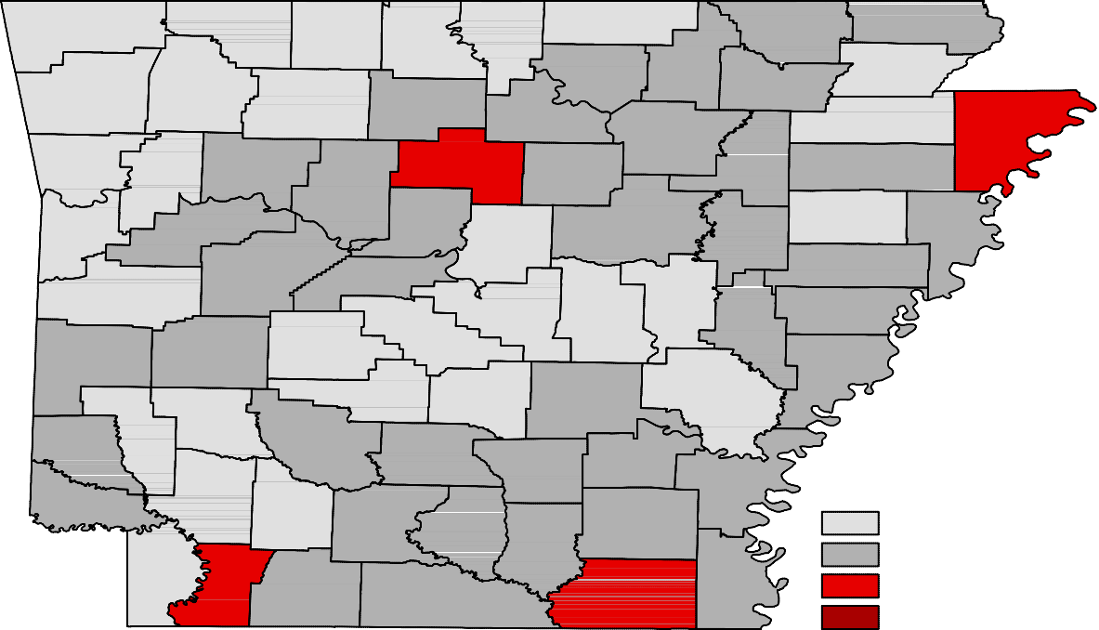Benton

Washington
Carroll

Madison

Boone

Newton

Marion

Searcy

Baxter

Stone
Fulton

Izard

Sharp

Randolph

Lawrence
Clay

Greene

Craighead

Mississippi

Crawford

Franklin

Johnson

Pope

Van Buren

Cleburne
Independence

Jackson

Poinsett

Cross

Sebastian

Scott
Logan

Yell
Conway

Perry

Saline

Faulkner

Pulaski
White

Lonoke

Prairie
Woodruff

Monroe

St. Francis

Lee
Crittenden

Polk

Sevier
Montgomery

Pike
Howard
Garland

Hot Spring

Clark
Dallas

Grant

Jefferson

Lincoln
Cleveland

Arkansas

Desha

Phillips

Unemployment Rates

Little River
Hempstead

Miller
Nevada

Ouachita

Calhoun

Bradley

Drew

Chicot

< or = 4.0%

4.1% - 6.0%

Lafayette
Columbia
Union
Ashley
6.1% - 8.0%

> 8.0% [NONE]

Ranked by Unemployment Rates

August 2016- Not Seasonally Adjusted

Rank  1 | County  Washington | Rate  2.6 | Rank  25 | County  Pike | Rate  3.9 | Rank  50 | County  Little River | Rate  4.9
2 | Benton | 2.7 | 27 | Baxter | 4.0 | 52 | Clay | 5.0
2 | Carroll | 2.7 | 27 | Garland | 4.0 | 52 | Independence | 5.0
4 | Madison | 3.0 | 27 | Greene | 4.0 | 52 | St. Francis | 5.0
4 | Saline | 3.0 | 27 | Miller | 4.0 | 55 | Calhoun | 5.1
6 | Arkansas | 3.1 | 31 | Poinsett | 4.1 | 55 | Dallas | 5.1
6 | Craighead | 3.1 | 32 | Searcy | 4.2 | 55 | Desha | 5.1
8 | Grant | 3.2 | 33 | Logan | 4.3 | 58 | Izard | 5.2
8 | Howard | 3.2 | 33 | Yell | 4.3 | 58 | Sharp | 5.2
8 | Lonoke | 3.2 | 35 | Clark | 4.4 | 58 | Woodruff | 5.2
11 | Boone | 3.3 | 35 | Cleveland | 4.4 | 61 | Phillips | 5.4
12 | Newton | 3.5 | 35 | Crittenden | 4.4 | 62 | Ouachita | 5.5
12 | Pulaski | 3.5 | 35 | Perry | 4.4 | 62 | Union | 5.5
12 | Sebastian | 3.5 | 39 | Lawrence | 4.5 | 64 | Cleburne | 5.6
15 | Hot Spring | 3.6 | 40 | Lee | 4.6 | 64 | Columbia | 5.6
15 | Nevada | 3.6 | 40 | Monroe | 4.6 | 66 | Drew | 5.7
15 | Prairie | 3.6 | 40 | Montgomery | 4.6 | 67 | Bradley | 5.8
15 | Scott | 3.6 | 40 | Polk | 4.6 | 67 | Chicot | 5.8
19 | Crawford | 3.7 | 44 | Pope | 4.7 | 67 | Conway | 5.8
19 | Faulkner | 3.7 | 44 | Randolph | 4.7 | 70 | Jackson | 5.9
19 | Hempstead | 3.7 | 44 | White | 4.7 | 70 | Jefferson | 5.9
19 | Marion | 3.7 | 47 | Johnson | 4.8 | 72 | Ashley | 6.1
23 | Franklin | 3.8 | 47 | Sevier | 4.8 | 72 | Lafayette | 6.1
23 | Fulton | 3.8 | 47 | Stone | 4.8 | 74 | Van Buren | 6.2
25 | Cross | 3.9 | 50 | Lincoln | 4.9 | 75 | Mississippi | 7.2

Civilian Labor Force Estimates

LWDA Labor Force Estimates (Not Seasonally Adjusted)

August 2016  LWDA CLF Emp Unemp Rate |  |  |  |  | CLF | July 2016  Emp Unemp |  | Rate | CLF | August 2015  Emp Unemp |  | Rate
Central (minus LR) 251,477 242,905 8,572 3.4 256,680 246,970 9,710 3.8 248,237 237,524 10,713 4.3
City of Little Rock | 98,441 | 95,065 | 3,376 | 3.4 | 100,638 | 96,800 | 3,838 | 3.8 | 97,394 | 92,994 | 4,400 | 4.5
Eastern | 48,883 | 46,634 | 2,249 | 4.6 | 48,642 | 46,117 | 2,525 | 5.2 | 48,978 | 45,834 | 3,144 | 6.4
North Central | 96,077 | 91,225 | 4,852 | 5.1 | 95,959 | 90,399 | 5,560 | 5.8 | 94,968 | 88,951 | 6,017 | 6.3
Northeast | 119,595 | 114,583 | 5,012 | 4.2 | 120,598 | 114,921 | 5,677 | 4.7 | 118,509 | 111,902 | 6,607 | 5.6
Northwest | 309,848 | 301,049 | 8,799 | 2.8 | 315,020 | 304,769 | 10,251 | 3.3 | 301,909 | 290,826 | 11,083 | 3.7
Southeast | 83,881 | 79,595 | 4,286 | 5.1 | 84,648 | 79,868 | 4,780 | 5.6 | 83,290 | 77,973 | 5,317 | 6.4
Southwest | 95,164 | 90,668 | 4,496 | 4.7 | 96,122 | 91,030 | 5,092 | 5.3 | 94,295 | 88,955 | 5,340 | 5.7
West Central | 133,810 | 127,975 | 5,835 | 4.4 | 135,448 | 128,570 | 6,878 | 5.1 | 132,667 | 125,384 | 7,283 | 5.5
Western | 114,447 | 110,161 | 4,286 | 3.7 | 115,411 | 110,451 | 4,960 | 4.3 | 113,811 | 108,180 | 5,631 | 4.9
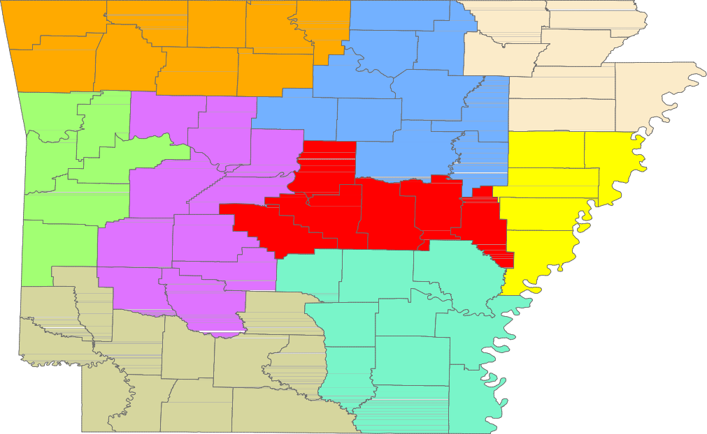

Benton

Washington
Carroll

Madison

Boone

Newton

Marion

Searcy

Baxter

Stone
Fulton

Izard

Sharp

Randolph

Lawrence
Clay

Greene

Craighead

Mississippi

Crawford

Franklin

Johnson

Pope

Van Buren

Cleburne
Independence

Jackson

Poinsett

Cross

Sebastian

Scott
Logan

Yell
Conway

Perry

Saline

Faulkner

Pulaski
White

Lonoke

Prairie
Woodruff

Monroe

St. Francis

Lee
Crittenden

Polk

Sevier
Montgomery

Pike
Howard
Garland

Hot Spring

Clark
Dallas

Grant

Jefferson

Lincoln
Cleveland

Arkansas

Desha

Phillips

Little River
Hempstead

Miller

Nevada

Ouachita

Calhoun

Bradley

Drew

Chicot

Lafayette
Columbia
Union
Ashley

Central (minus LR) Eastern
North Central
Northeast
Northwest
Southeast
Southwest
West Central
Western

www.discover.arkansas.gov 18

